A Recurrent CNN for Automatic Detection and

Classification of Coronary Artery Plaque and Stenosis in Coronary CT Angiography用于冠状动脉CT血管造影中冠状动脉斑块和狭窄自动检测和分类的递归卷积神经网络

Majd Zreik, Robbert W. van Hamersvelt, Jelmer M. Wolterink,

Tim Leiner, Max A. Viergever, Ivana Isgumˇ

*Abstract*—Various types of atherosclerotic plaque and varying grades of stenosis could lead to different management of patients with coronary artery disease. Therefore, it is crucial to detect and classify the type of coronary artery plaque, as well as to detect and determine the degree of coronary artery stenosis. This study includes retrospectively collected clinically obtained coronary CT angiography (CCTA) scans of 163 patients. In these, the centerlines of the coronary arteries were extracted and used to reconstruct multi-planar reformatted (MPR) images for the coronary arteries. To define the reference standard, the presence and the type of plaque in the coronary arteries (no plaque, non-calcified, mixed, calcified), as well as the presence and the anatomical significance of coronary stenosis (no stenosis, nonsignificant i.e. *<*50% luminal narrowing, significant i.e. ≥50% luminal narrowing) were manually annotated in the MPR images by identifying the start- and end-points of the segment of the artery affected by the plaque. To perform automatic analysis, a multi-task recurrent convolutional neural network is applied on coronary artery MPR images. First, a 3D convolutional neural network is utilized to extract features along the coronary artery. Subsequently, the extracted features are aggregated by a recurrent neural network that performs two simultaneous multiclass classification tasks. In the first task, the network detects and characterizes the type of the coronary artery plaque. In the second task, the network detects and determines the anatomical significance of the coronary artery stenosis. The network was trained and tested using CCTA images of 98 and 65 patients, respectively. For detection and characterization of coronary plaque, the method achieved an accuracy of 0.77. For detection of stenosis and determination of its anatomical significance, the method achieved an accuracy of 0.80. The results demonstrate that automatic detection and classification of coronary artery plaque and stenosis are feasible. This may enable automated triage of patients to those without coronary plaque and those with coronary plaque and stenosis in need for further cardiovascular workup. 不同类型的动脉粥样硬化斑块和不同程度的狭窄会导致冠心病患者的不同处理。因此，对冠状动脉斑块类型的检测和分类，以及对冠状动脉狭窄程度的检测和判定是至关重要的。这项研究包括163名患者的回顾性收集的临床获得的冠状动脉CT血管造影(CCTA)扫描。在这些方法中，提取了冠状动脉的中心线，并将其用于重建冠状动脉的多平面重建(MPR)图像。为了确定参考标准，通过识别受斑块影响的动脉段的起始点和终点，在多平面重组图像中手动注释冠状动脉中斑块的存在和类型(无斑块、非钙化、混合型、钙化)，以及冠状动脉狭窄的存在和解剖学意义(无狭窄，无显著性，即<50%管腔狭窄，显著，即≥50%管腔狭窄)，通过识别受斑块影响的动脉段的起始点和终点，在MPR图像中手动注释冠状动脉狭窄的存在和类型，以及冠状动脉狭窄的存在和解剖学意义(无狭窄，不显著，即<50%管腔狭窄，显著，即冠状动脉50%管腔狭窄)。为了实现自动分析，将多任务递归卷积神经网络应用于冠状动脉MPR图像。首先，利用三维卷积神经网络提取冠状动脉沿线的特征。随后，通过执行两个同时的多类分类任务的递归神经网络对提取的特征进行聚合。在第一个任务中，网络检测并表征冠状动脉斑块的类型。在第二个任务中，该网络检测并确定冠状动脉狭窄的解剖学意义。分别用98例和65例患者的CCTA图像对网络进行训练和测试。对于冠状动脉斑块的检测和表征，该方法达到了0.77的准确率。对于狭窄的检测和其解剖学意义的确定，该方法达到了0.80的准确率。结果表明，冠状动脉斑块和狭窄的自动检测和分类是可行的。这可能会使患者自动分流到那些没有冠状动脉斑块的患者和那些有冠状动脉斑块和狭窄的患者，这些患者需要进一步的心血管检查。

*Index Terms*—Coronary artery stenosis, Coronary artery plaque, Recurrent convolutional neural network, Coronary CT angiography, Deep learning, Automatic Classification

|  |
| --- |
| M. Zreik, J. M. Wolterink, and I. Isgum are with the Image Sciencesˇ Institute, University Medical Center Utrecht, The Netherlands (e-mail: m.zreik@umcutrecht.nl).  R. W. van Hamersvelt is with the Department of Radiology, University Medical Center Utrecht, The Netherlands.  T. Leiner is with the Department of Radiology, University Medical Center Utrecht and Utrecht University, The Netherlands.  M. A. Viergever is with the Image Sciences Institute, University Medical Center Utrecht and Utrecht University, The Netherlands.  Copyright (c) 2018 IEEE. Personal use of this material is permitted. However, permission to use this material for any other purposes must be obtained from the IEEE by sending a request to pubs-permissions@ieee.org. |

I. INTRODUCTION

arXiv:1804.04360v4 [cs.CV] 10 Dec 2018

Coronary artery disease (CAD) is the most common type of heart disease [1]. CAD occurs when atherosclerotic plaque builds up in the wall of the coronary arteries. This may lead to stenosis, i.e. narrowing or occlusion of the coronary artery lumen, limiting blood supply to the myocardium and potentially leading to myocardial ischemia. Atherosclerotic plaque can be classified according to its composition into calcified plaque, non-calcified plaque, and mixed plaque, i.e plaque containing calcified and non-calcified components [2]. Calcified plaque is considered stable and its amount in the coronary arteries is a strong predictor of cardiovascular events [3]. Unlike calcified plaque, non-calcified and mixed plaque are considered unstable and more prone to rupture. Such rupture may lead to acute coronary syndrome and could result in irreversible damage to the myocardium, i.e. myocardial infarction [4], [5]. As different types of plaque and varying grades of stenosis lead to different patient management strategies, it is crucial to detect and characterize coronary artery plaque and stenosis [6], [7]. 冠心病(CAD)是最常见的心脏病类型[1]。当动脉粥样硬化斑块在冠状动脉壁上积聚时，就会发生冠心病。这可能会导致狭窄，即冠状动脉管腔变窄或闭塞，限制心肌的血液供应，并可能导致心肌缺血。动脉粥样硬化斑块按其组成可分为钙化斑块、非钙化斑块和混合斑块，即含有钙化和非钙化成分的斑块[2]。钙化斑块被认为是稳定的，其在冠状动脉中的数量是心血管事件的有力预测因子[3]。与钙化斑块不同，非钙化和混合斑块被认为是不稳定的，更容易破裂。这种破裂可能导致急性冠脉综合征，并可能对心肌造成不可逆转的损害，即心肌梗死[4]、[5]。由于不同类型的斑块和不同程度的狭窄导致不同的患者管理策略，因此检测和表征冠状动脉斑块和狭窄是至关重要的[6]，[7]。

Coronary CT angiography (CCTA) is a well-established modality for identification, as well as for exclusion, of patients with suspected CAD. It allows for noninvasive detection and characterization of coronary artery plaque and grading of coronary artery stenosis [8]. To day, these tasks are typically performed in the clinic by visual assessment [7], or semi-automatically by first utilizing lumen and arterial wall segmentation and thereafter, defining the presence of plaque or stenosis [9]. However, the former suffers from substantial interobserver variability, even when performed by experienced experts [10], while the latter is dependent on coronary artery lumen and wall segmentation which is typically time-consuming and cumbersome, especially in images with extensive atherosclerotic plaque or imaging artefacts [9]. 冠状动脉CT血管造影(CCTA)是一种公认的鉴别和排除疑似冠心病患者的方法。它允许无创检测和表征冠状动脉斑块和冠状动脉狭窄分级[8]。迄今为止，这些任务通常在临床上通过视觉评估[7]来执行，或者通过首先利用管腔和动脉壁分割，然后定义斑块或狭窄的存在来半自动执行[9]。然而，前者即使由经验丰富的专家进行，也存在显著的观察者间可变性[10]，而后者依赖于冠状动脉腔和壁的分割，这通常既耗时又麻烦，尤其是在具有大量动脉粥样硬化斑块或成像伪影的图像中[9]。

Given the importance of plaque detection, a number of methods for coronary artery plaque detection and quantification have been proposed. Thus far, (semi-)automatic methods have been designed to detect either calcified or non-calcified plaque. Several methods have been developed to automatically segment and quantify calcifications in the coronary arteries in noncontrast CT and CCTA scans (e.g. [3], [11], [12], [13]). These methods employ machine learning to analyze axial reconstruction of CT scans. Typically, an excellent performance approaching the level of an expert is achieved [3]. On the contrary, automatic detection and quantification of non-calcified coronary plaque using CCTA has been less investigated. While the visual detection of calcified plaque is straightforward in CT/CCTA due to its higher CT density, the detection of noncalcified and especially mixed plaque is more challenging because of low contrast with adjacent tissues. Therefore, unlike methods detecting calcifications, standard visual evaluation as well as (semi-)automatic approaches detecting non-calcified plaque typically analyze straightened multi-planar reformatted (MPR) images. MPR images allow better visualization of the arterial lumen and identification of difficult to delineate noncalcified plaque in the arterial wall. To detect and quantify noncalcified plaque, previously proposed methods have performed manual or semi-automatic thresholding on CT values in predefined regions of interest [14], [15]. Typically, these methods require substantial manual interactions by experts. Even though the presence of mixed plaque is usually reported in clinical visual assessment, to the best of our knowledge, automatic methods detecting and quantifying such plaque have not yet been presented. 鉴于斑块检测的重要性，已经提出了许多冠状动脉斑块检测和量化的方法。迄今为止，(半自动)方法已经被设计用于检测钙化或非钙化斑块。已经开发了几种方法来在非对比CT和CCTA扫描中自动分割和量化冠状动脉中的钙化(例如[3]，[11]，[12]，[13])。这些方法使用机器学习来分析CT扫描的轴向重建。通常，会取得接近专家水平的出色表现[3]。相反，使用CCTA自动检测和量化非钙化冠状动脉斑块的研究较少。虽然钙化斑块的视觉检测由于其较高的CT密度而在CT/CCTA中是直接的，但是由于与邻近组织的低对比度，检测未钙化的尤其是混合斑块更具挑战性。因此，与检测钙化的方法不同，标准视觉评估以及检测非钙化斑块的(半自动)方法通常分析拉直的多平面重组(MPR)图像。多平面重建图像可以更好地显示动脉腔，并识别动脉壁中难以描绘的非钙化斑块。为了检测和量化未钙化斑块，先前提出的方法已经对预定感兴趣区域的ct值执行了手动或半自动阈值化[14]，[15]。通常，这些方法需要专家大量的人工交互。尽管临床视觉评估中通常会报告混合斑块的存在，但据我们所知，尚未出现检测和量化这种斑块的自动方法。

As stenosis detection and grading is highly important, a number of methods have been developed to (semi-)automatically detect and grade coronary artery stenosis in CCTA [9]. These methods either utilize machine learning approaches to analyze the vicinity of the coronary artery centerline (e.g. [16], [17], [18]), or segment arterial lumen (e.g. [19], [20], [21], [22], [23]). Algorithms that utilize lumen segmentation for stenosis detection first delineate coronary artery lumen and subsequently detect and quantify stenosis by analyzing local changes and anomalies in the lumen of the delineated artery. Shahzad et al. [21] first extracted the centerline of the artery and subsequently employed a graph cut approach and robust kernel regression to segment the arterial lumen. Thereafter, to detect and grade coronary stenosis, the diameter of the segmented lumen was compared with the expected diameter of a healthy lumen. The expected diameter of the healthy lumen was estimated by regression on the diameters of the lumina along the coronary artery. Wang et al. [22] employed a level-set model to separately segment the inner and the outer arterial walls. Thereafter, a comparison between these arterial wall profiles enabled the detection and grading of stenosis. Furthermore, algorithms that exploit machine learning for stenosis detection first compute a number of features along the centerline of an artery to describe local image intensities and arterial geometry. Subsequently, they use a supervised classifier to detect and quantify stenosis. For example, Zuluaga et al. [17] formulated arterial stenosis as anomalous vascular cross-sections along the artery centerline. The shape of the vascular cross-sections and their intensity profiles were described by hand-crafted features, and then the abnormal vascular cross-sections were detected by a support vector machine. Sankaran et al. [18] first estimated healthy diameters of the coronary arteries using downstream and upstream properties of coronary tree vasculature as features for random forest regressors. Then, the degree of a stenosis was estimated based on the ratio of the local artery diameter, estimated using maximum inscribed spheres, to the estimated healthy diameter. 由于狭窄检测和分级非常重要，CCTA已经开发了许多方法来(半自动)检测和分级冠状动脉狭窄[9]。这些方法或者利用机器学习方法来分析冠状动脉中心线附近(例如[16]，[17]，[18])，或者分割动脉腔(例如[19]，[20]，[21]，[22]，[23])。利用管腔分割进行狭窄检测的算法首先描绘冠状动脉管腔，随后通过分析所描绘的动脉管腔中的局部变化和异常来检测和量化狭窄。Shahzad等人[21]首先提取动脉的中心线，随后采用图切割方法和稳健核回归分割动脉管腔。此后，为了检测和分级冠状动脉狭窄，将分段管腔的直径与健康管腔的预期直径进行比较。健康腔的预期直径通过沿冠状动脉的腔直径的回归来估计。王等人[22]采用水平集模型分别分割动脉内壁和动脉外壁。此后，这些动脉壁轮廓之间的比较使得狭窄的检测和分级成为可能。此外，利用机器学习进行狭窄检测的算法首先计算沿动脉中心线的多个特征，以描述局部图像强度和动脉几何形状。随后，他们使用监督分类器来检测和量化狭窄。例如，Zuluaga等人[17]将动脉狭窄表述为沿动脉中心线的异常血管横截面。通过手工特征描述血管横截面的形状及其强度分布，然后通过支持向量机检测异常血管横截面。Sankaran等人[18]首次使用冠状动脉树脉管系统的下游和上游特性作为随机森林回归的特征来估计冠状动脉的健康直径。然后，基于使用最大内接球体估计的局部动脉直径与估计的健康直径的比率来估计狭窄程度。

Here, we present a method to automatically detect and characterize the type of coronary artery plaque, as well as to detect and determine the anatomical significance of coronary artery stenosis in CCTA scans. To perform the automatic comprehensive analysis, a multi-task recurrent convolutional neural network (RCNN) is employed to analyze the vicinity along the extracted centerline in an MPR image and to simultaneously carry out two classification tasks. In the first task, the network detects and characterizes the type of the coronary artery plaque, i.e. no plaque, non-calcified, mixed or calcified plaque. In the second task, the network detects and determines the anatomical significance of the coronary artery stenosis, i.e. no stenosis, non-significant or significant stenosis. The RCNN analyzes the vicinity along the artery centerline, which is defined as a sequence of small volumes along the centerline. This definition enables the RCNN, built from a 3D convolutional neural network (CNN) and a recurrent neural network (RNN) connected in series [24], to extract image features from smaller volumes regardless of plaque length, and then to aggregate all features extracted along the plaque. Our contributions are fourfold. Firstly, we propose to jointly classify plaque and stenosis, while previously proposed methods have detected either plaque or stenosis. Secondly, unlike previous automatic methods, our method does not require segmentation of the coronary artery lumen and/or wall nor exploiting geometric information about the artery lumen. Instead, it only requires the coronary artery centerline. Thirdly, we are the first to use deep neural networks to approach the task of coronary artery plaque and stenosis analysis, or more specifically a 3D-CNN paired with an RNN to analyze medical data. Finally, previous works for classifying coronary artery plaque require detailed reference annotations for each voxel affected by the plaque. This kind of manual annotations is extremely challenging and time consuming. In the presented work, we employ only weakly annotated reference (start- and end-points of a lesion with a single label for all voxels in that lesion) to detect and characterize the plaque and thereby substantially simplify the manual annotation procedure.这里，我们提出了一种自动检测和表征冠状动脉斑块类型的方法，以及在CCTA扫描中检测和确定冠状动脉狭窄的解剖学意义的方法。为了进行自动综合分析，采用多任务递归卷积神经网络(RCNN)来分析MPR图像中沿提取的中心线的邻域，并同时执行两个分类任务。在第一个任务中，网络检测并表征冠状动脉斑块的类型，即无斑块、非钙化、混合或钙化斑块。在第二个任务中，网络检测并确定冠状动脉狭窄的解剖学意义，即没有狭窄、不显著或显著狭窄。RCNN沿着动脉中心线分析附近区域，该中心线被定义为沿着中心线的一系列小体积。该定义使得由串联的3D卷积神经网络(CNN)和递归神经网络(RNN)构建的RCNN[24]能够从更小的体积中提取图像特征，而不管斑块长度如何，然后聚集沿着斑块提取的所有特征。我们的贡献是四倍。首先，我们提出联合分类斑块和狭窄，而以前提出的方法已经检测到斑块或狭窄。其次，与以前的自动方法不同，我们的方法不需要分割冠状动脉腔和/或壁，也不需要利用关于动脉腔的几何信息。相反，它只需要冠状动脉中心线。第三，我们是第一个使用深度神经网络来处理冠状动脉斑块和狭窄分析任务的人，或者更具体地说，是第一个与RNN配对来分析医学数据的3D-CNN。最后，以前对冠状动脉斑块进行分类的工作需要对斑块影响的每个体素进行详细的参考注释。这种手动注释极具挑战性且耗时。在目前的工作中，我们仅采用弱注释参考(病变的起点和终点，该病变中的所有体素都有单个标记)来检测和表征斑块，从而大大简化了手动注释过程。

The remainder of the manuscript is organized as follows. Section II describes the data and reference standard. Section III describes the method and Section IV describes the evaluation. Section V reports our experimental results, which are then discussed in Section VI.

II. DATA

# A. Patient and image data

This study includes retrospectively collected clinically obtained CCTA scans of 163 patients (age: 59*.*2 ± 8*.*8 years, 126 males) acquired in our hospital between 2012 and 2016. The Institutional Ethical Review Board waived the need for informed consent. All CCTA scans were acquired using an ECG-triggered step-and-shoot protocol on a 256-detector row scanner (Philips Brilliance iCT, Philips Medical, Best, The Netherlands). A tube voltage of 120 kVp and tube current between 210 and 300 mAs were used. For patients ≤ 80 kg contrast medium was injected using a flow rate of 6 mL/s for a total of 70 mL iopromide (Ultravist 300 mg I/mL, Bayer Healthcare, Berlin, Germany), followed by a 50 mL mixed contrast medium and saline (50:50) flush, and a 30 mL saline flush. For patients *>* 80 kg the flow rate was 6.7 mL/s and the volumes of the boluses were 80, 67 and 40 mL, respectively. Images were reconstructed to an in-plane resolution ranging from 0.38 to 0.56 mm, with 0.9 mm slice thickness and 0.45 mm slice increment. 本研究回顾性收集了2012年至2016年间在我院获得的163名患者(年龄:59.2±8.8岁，126名男性)的临床获得的CCTA扫描结果。机构伦理审查委员会放弃了知情同意的要求。所有CCTA扫描都是在256探测器行扫描仪上使用心电图触发的步进拍摄协议获得的(荷兰贝斯特，飞利浦医疗，飞利浦华晨信通技术)。使用120千伏安的管电压和210至300毫安的管电流。对于≤ 80千克的患者，使用6毫升/秒的流速注射造影剂，共注射70毫升碘普罗胺(Ultravist 300毫克碘/毫升，德国柏林拜耳医疗保健公司)，然后注射50毫升混合3造影剂和生理盐水(50:50)冲洗液，最后注射30毫升生理盐水冲洗液。对于体重> 80公斤的患者，流速为6.7毫升/秒，弹丸体积分别为80、67和40毫升。图像被重建为0.38至0.56毫米的面内分辨率，具有0.9毫米的切片厚度和0.45毫米的切片增量。

In each CCTA image, centerlines of the coronary arteries were extracted using the method previously described by Wolterink et al. [25]. The method requires manual placement of a single seed point in the artery of interest, after which the arterial centerline is extracted between the ostium and the most distal point as visualized in the CCTA image. Using the extracted centerlines, a 0.3 mm isotropic straightened MPR image was reconstructed for each artery and used for further analysis. 在每张CCTA图像中，冠状动脉的中心线是使用Wolterink等人[25]之前描述的方法提取的。该方法需要在感兴趣的动脉中手动放置单个种子点，之后在开口和CCTA图像中可视化的最远端点之间提取动脉中心线。使用提取的中心线，为每个动脉重建0.3毫米各向同性拉直的多平面重建图像，并用于进一步分析。

# B. Reference standard

To define a reference standard for atherosclerotic plaque and coronary artery stenosis, MPR images of coronary arteries were employed (Fig. 1). As only arteries with a diameter greater than 1.5 mm are clinically evaluated with CCTA [7], only those were annotated in this study. Plaque type and anatomical significance of the stenosis were manually annotated by an expert using custom-built software and following the guidelines of the Society of Cardiovascular Computed Tomography (SCCT) for reporting coronary artery disease [7]. For each plaque, the expert marked its start- and end-points, its type (*noncalcified*, *calcified*, or *mixed* i.e. containing both non-calcified and calcified components), and the anatomical significance of the stenosis caused by the plaque (*non-significant* i.e. with *<* 50% luminal narrowing, *significant* i.e. with ≥ 50% luminal narrowing). The significance of a stenosis was determined by visual estimation of the maximal grade of luminal narrowing caused by the plaque. Note that the plaque voxels were not segmented, but only the part of the artery containing the plaque was identified (Fig. 1b). The expert also annotated a number of segments of arteries without plaque and stenosis in different patients. We refer to the annotated and analyzed parts of the arteries as segments. However, note that these are not the anatomically defined coronary artery segments. 为了定义动脉粥样硬化斑块和冠状动脉狭窄的参考标准，采用了冠状动脉的多平面重建图像(图1)。由于CCTA只有直径大于1.5毫米的动脉进行临床评估[7]，因此本研究仅对那些进行了注释。斑块类型和狭窄的解剖意义由专家使用定制软件并遵循心血管计算机断层扫描学会(SCCT)报告冠状动脉疾病的指南手动注释[7]。对于每个斑块，专家标记其起点和终点、类型(非钙化、钙化或混合，即包含非钙化和钙化成分)以及斑块引起的狭窄的解剖学意义(非显著性，即< 50%管腔狭窄，显著性，即≥ 50%管腔狭窄)。狭窄的重要性通过目测斑块引起的最大管腔狭窄程度来确定。注意，斑块体素没有被分割，但是仅包含斑块的动脉部分被识别(图1b)。这位专家还对不同患者的一些没有斑块和狭窄的动脉段进行了注释。我们将动脉的注释和分析部分称为段。但是，请注意，这些不是解剖学上定义的冠状动脉段。

As patient management and treatment strategies depend on diagnosis at the segment-, artery- and patient-level [6], [7], we additionally evaluate the ability of the proposed method to detect stenosis and to classify its anatomical significance on an artery- and patient-level. Therefore, segment-level labels provided by the expert were translated to the artery- and patient-level as follows. Arteries were labeled according to the most severe stenosis significance among their segments. If no stenosis of any significance was found in any of the annotated segments, the artery was considered non-stenotic. Likewise, patients were labeled according to the most severe stenosis significance among their arteries, or considered as having no stenosis. 由于患者管理和治疗策略取决于分段，动脉和患者水平的诊断[6]，[7]，我们还评估了所提出的方法检测狭窄的能力，并在动脉中分类其解剖学意义和患者水平。因此，专家提供的分部级标签被翻译成如下所述动脉和患者水平。根据其细分市场中最严重的狭窄意义标记动脉。如果在任何注释的段中发现任何显着性的狭窄，则动脉被认为是非狭窄的。同样，患者根据动脉中最严重的狭窄意义标记，或被视为没有狭窄。

The dataset of 163 patients contained 1259 manually labeled arterial segments in 534 arteries. The manually annotated segments included 37 non-calcified, 161 mixed and 317 calcified plaques that caused non-significant stenosis. Additionally, there were segments with 29 non-calcified, 91 mixed and 41 calcified plaques that caused significant stenosis. Moreover, 583 segments without plaque and stenosis were annotated. Of the annotated segments, 528 were in the left anterior descending artery (LAD) or one of its branches, 305 were in the left circumflex artery (LCX) or one of its branches, and 426 were in the right coronary artery (RCA) or one of its branches. 163名患者的数据集包含534条动脉中的1259个手动标记的动脉段。人工标注的节段包括37个未钙化的、161个混合的和317个引起非显著狭窄的钙化斑块。此外，有29个非钙化段、91个混合段和41个钙化斑块导致明显狭窄。此外，对583个没有斑块和狭窄的节段进行了注释。其中528个位于左前降支或其分支，305个位于左回旋支或其分支，426个位于右冠状动脉或其分支。

To assess the interobserver agreement, a second trained observer, blinded to the reference standard, annotated the same set of arteries following the same guidelines.

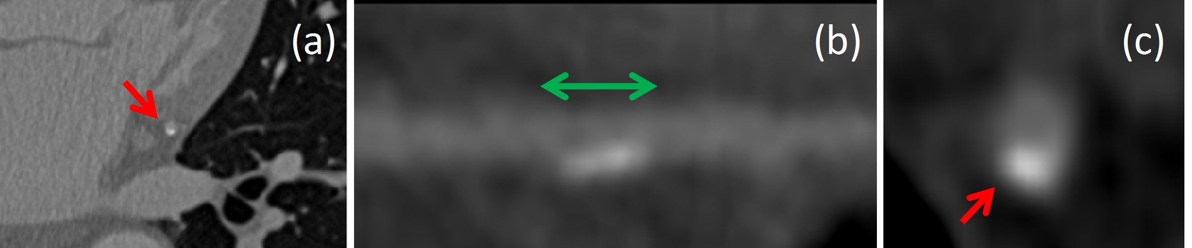

Figure 1. (a) Axial and (b) straightened MPR image with longitudinal view, and (c) cross-sectional view showing coronary artery in CCTA. This artery contains a lesion (spanning the green arrow) labeled as containing calcified plaque with non-significant stenosis. Red arrows indicate the location of this plaque in other views. a)轴向和(b)纵向的直的多平面重建图像，和(c)显示CCTA冠状动脉的横截面图。该动脉包含一个病变(跨越绿色箭头)，标记为包含钙化斑块，狭窄程度不明显。红色箭头表示这块牌匾在其他视图中的位置。

III. METHOD

To detect and characterize the type of coronary artery plaque, as well as to detect and determine the anatomical significance of coronary artery stenosis, an RCNN is designed. An illustration of the proposed workflow is shown in Fig. 2. Recently, RCNNs have been successfully used for video recognition and description (e.g. [26], [27], [28]), object recognition (e.g.

[29]), speech modeling [30], and in medical image analysis (e.g. [31], [32], [33], [34]). RCNNs connect a CNN with an RNN in series to analyze a sequential input. The CNN extracts image features for each element of the sequence independently (e.g. frame in a video clip, word in a sentence, cardiac phase in cardiac cycle), and these extracted features are then fed to the RNN that analyzes the relevant sequential dependencies in the whole sequence. 为了检测和表征冠状动脉斑块的类型，以及检测和确定冠状动脉狭窄的解剖学意义，设计了一种RCNN。图2显示了建议的工作流程。最近，RCNNs已经成功地用于视频识别和描述(例如[26]，[27]，[28])，对象识别(例如[29])，语音建模[30]，以及医学图像分析(例如[31]，[32]，[33]，[34])。无线通信网络将CNN与RNN串联起来，分析连续输入。CNN独立地为序列的每个元素提取图像特征(例如，视频剪辑中的帧、句子中的单词、心动周期中的心动时相)，然后将这些提取的特征馈送给RNN，后者分析整个序列中的相关序列相关性。

In this work, the reference was defined following clinical practice where parts of the arteries are classified with respect to plaque and stenosis. Hence, only arterial segments containing plaque were identified, instead of e.g. annotating all crosssections of the arterial lumen or all voxels in the arterial wall. Given that the appearance of the plaque along the whole segment is important for characterization of its type and for determination of stenosis presence and significance, the artery along the entire segment needs to be analyzed. Instead of extracting a single, possibly large, volume covering the segment at hand, we represent the segment as a sequence of small volumes along its centerline. This enables us to employ a relatively shallow CNN to extract image features from smaller volumes independently. A shallow CNN that analyzes smaller volumes may have fewer parameters and is therefore less prone to overfitting. To aggregate and analyze the features extracted from all small volumes along the segment, we employ an RNN. For the whole analyzed sequence, the network 1) detects and characterizes coronary artery plaque

i.e. classifies the segment as either containing no plaque, containing non-calcified, mixed or calcified plaque, and 2)

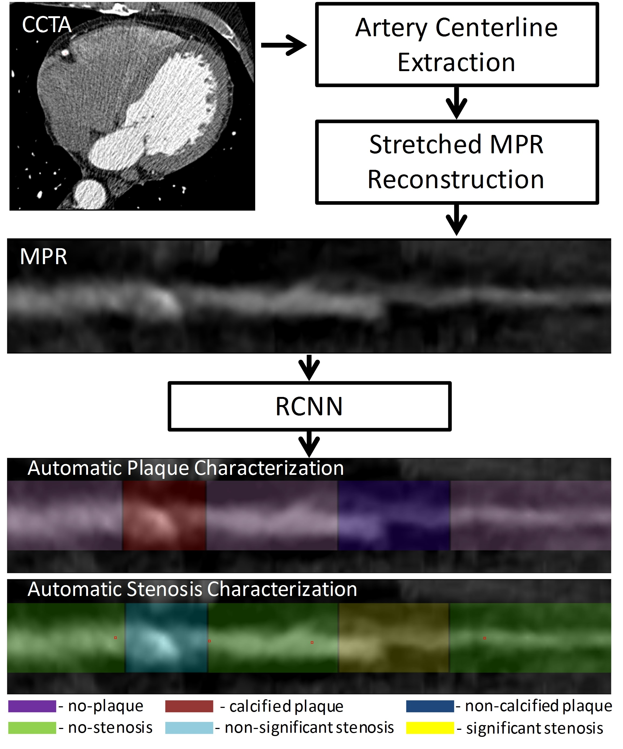

Figure 2. Illustration of the proposed workflow. In a CCTA scan, the centerlines of the coronary arteries are extracted and used to reconstruct stretched multiplanar reformatted (MPR) images for the coronary arteries. To perform the automatic analysis, a multi-task recurrent convolutional neural network (RCNN) is applied to coronary artery MPR images to perform two simultaneous multi-class classification tasks. In the first task, the network detects and characterizes the type of the coronary artery plaque (no plaque, non-calcified, mixed, calcified). In the second task, the network detects and determines the anatomical significance of the coronary artery stenosis (no stenosis, nonsignificant i.e. *<* 50% luminal narrowing, significant i.e. ≥ 50% luminal narrowing). 建议工作流程的图示。在CCTA扫描中，提取冠状动脉的中心线，并用于重建冠状动脉的拉伸多平面重组图像。为了进行自动分析，将多任务递归卷积神经网络应用于冠状动脉多平面重建图像，以同时执行两个多类分类任务。在第一个任务中，网络检测并表征冠状动脉斑块的类型(无斑块、未钙化、混合、钙化)。在第二个任务中，网络检测并确定冠状动脉狭窄的解剖学意义(无狭窄，无显著性，即< 50%管腔狭窄，显著性，即≥ 50%管腔狭窄)。

detects and determines the anatomical significance of coronary artery stenosis, i.e. classifies the segment as either containing no stenosis, or containing non-significant or significant stenosis. 在这项工作中，参考文献是根据临床实践定义的，在临床实践中，根据斑块和狭窄对部分动脉进行分类。因此，仅识别包含斑块的动脉段，而不是例如注释动脉腔的所有横截面或动脉壁中的所有体素。考虑到沿整个节段的斑块外观对于其类型的表征和狭窄存在和重要性的确定很重要，需要分析沿整个节段的动脉。我们不是提取一个单一的、可能很大的体积来覆盖手头的线段，而是将线段表示为沿其中心线的一系列小体积。这使我们能够使用相对较浅的CNN从较小的体积中独立提取图像特征。分析较小体积的浅层CNN可能具有较少的参数，因此不太容易过度拟合。为了聚集和分析从沿着线段的所有小体积中提取的特征，我们采用了RNN。对于整个分析的序列，网络1)检测并表征冠状动脉斑块，即将该段分类为不含斑块、含非钙化、混合或钙化斑块，以及2)检测并确定冠状动脉狭窄的解剖学意义，即将该段分类为不含狭窄、或含非显著或显著狭窄

An illustration of the proposed RCNN is shown in Fig. 3. The input of the network is a sequence with a maximum length of 25 cubes of 25 × 25 × 25 voxels with stride of 5 voxels extracted from the MPR along the coronary artery centerline. The maximal length was chosen based on the longest annotated plaque in the training set. The size of the cube was chosen so that it contains the whole arterial lumen and the vicinity of the artery that may be needed in case of positive remodeling [7]. Each cube is analyzed by a 3D CNN. The CNN consists of three convolutional layers with kernels of

3×3×3 elements, with 32, 64, 128 filters, respectively. Each convolutional layer is followed by a 2×2×2 max-pooling layer and batch normalization [35]. The features extracted by the CNN are fed to the RNN. The RNN consists of 2 layers of 64 Gated Recurrent Units (GRUs) [36] each. Rectified linear units (ReLU) [37] are used in both CNN and RNN layers as activation functions, except for the output layer of the RNN. To perform both classification tasks simultaneously, the output of the last layer of the RNN is fed into two separate multi-class softmax classifiers. The first classifier has four output units for detection of plaque and characterization of its type (no-plaque, non-calcified, mixed, calcified). The second classifier has three output units for detection of stenosis and determination of its anatomical significance (no-stenosis, non-significant stenosis, significant stenosis). The RCNN has a total number of 340,295 parameters. 图3显示了建议的RCNN的图示。网络的输入是一个序列，最大长度为25个25 × 25 × 25体素的立方体，步长为5个体素，从沿冠状动脉中心线的多平面重建中提取。最大长度是根据训练集中注释最长的斑块来选择的。选择立方体的大小，以便它包含整个动脉腔和动脉附近，这在积极重塑的情况下可能是需要的[7]。每个立方体都由一个3DCNN进行分析。CNN由三个卷积层组成，卷积层的核为3×3×3元素，分别有32、64、128个滤波器。每个卷积层之后是一个2 × 2 × 2最大池层和批量归一化[35]。CNN提取的特征被输入RNN。RNN由两层64个门控循环单元组成，每层36个。除了RNN的输出层，整流线性单元(ReLU) [37]在CNN和RNN层中都用作激活函数。为了同时执行两个分类任务，RNN的最后一层的输出被馈送到两个独立的多类softmax分类器中。第一个分类器有四个输出单元，用于检测斑块并表征其类型(无斑块、无钙化、混合、钙化)。第二分类器具有三个输出单元，用于检测狭窄并确定其解剖学意义(无狭窄、无显著狭窄、显著狭窄)。RCNN总共有340，295个参数。

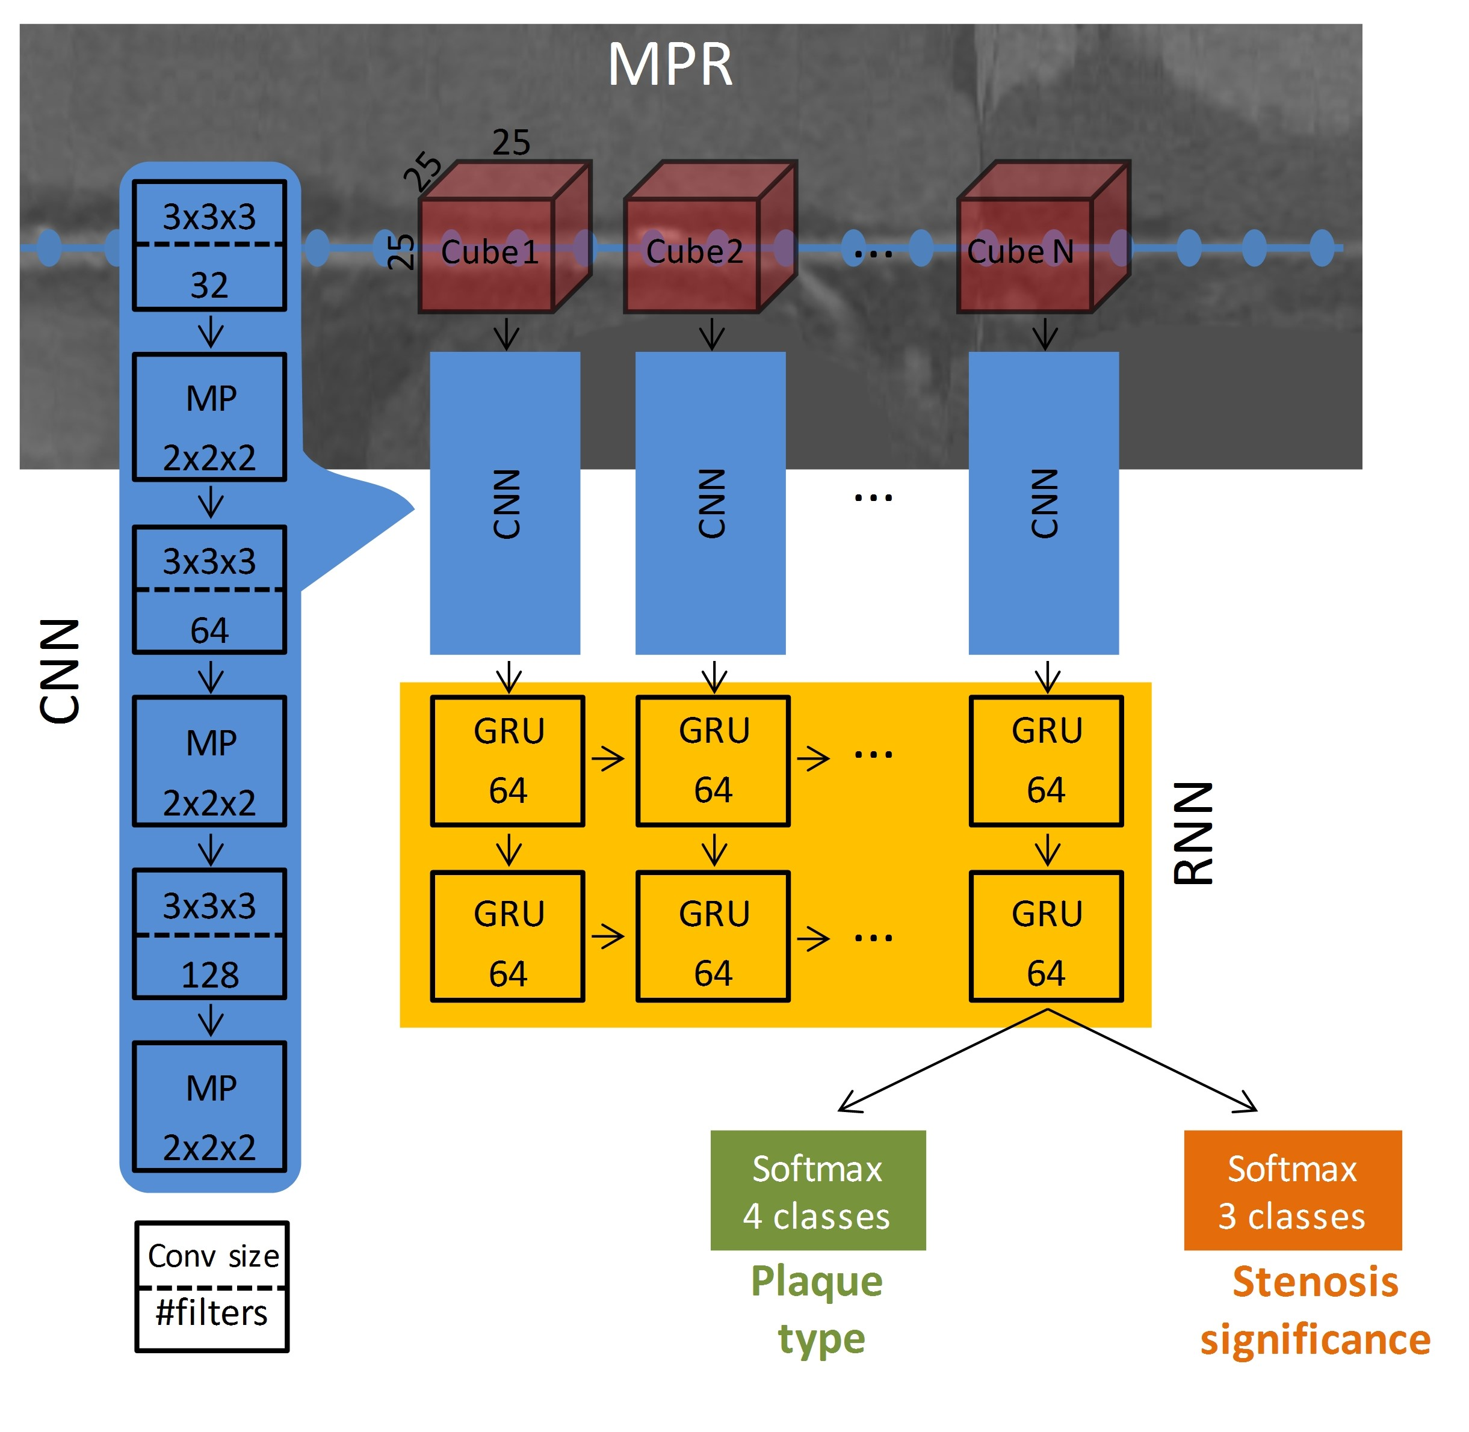

Figure 3. Overview of the proposed network. An MPR is obtained using the artery centerline points (blue dotted line). The input of the network is a sequence of cubes extracted from the MPR, along the artery centerline. A CNN extracts features out of 25×25×25 voxels cubes. Subsequently, an RNN processes the entire sequence using gated recurrent units (GRUs). The output of the RNN is fed into two softmax classifiers to simultaneously characterize plaque and stenosis. 拟议网络概述。使用动脉中心线点(蓝色虚线)获得多平面重建。网络的输入是沿着动脉中心线从多平面重建中提取的立方体序列。CNN从25 × 25 × 25体素立方体中提取特征。随后，RNN使用门控循环单位处理整个序列。RNN的输出被输入两个软最大分类器，以同时表征斑块和狭窄。

IV. EVALUATION

Performance of the network was evaluated on segment-, artery- and patient-levels. For segment-level evaluation, only the predicted labels along the centerlines that fall within the manually annotated segment boundaries were considered. For artery-level evaluation, all predicted labels along the complete artery centerline were taken into account. For patient-level evaluation, all predicted labels along the complete centerlines of all arteries of a patient were taken into account. 该网络的性能在分段、动脉和患者层面进行评估。对于段级评估，仅考虑位于手动注释段边界内的沿中心线的预测标签。对于动脉水平评估，所有沿着完整动脉中心线的预测标记都被考虑在内。对于患者级别的评估，沿着患者所有动脉的完整中心线的所有预测标记都被考虑在内。

An automatically labeled segment is considered to be a true positive in the classification of plaque type or stenosis significance when it has an overlap of at least 1 mm with a manually annotated segment sharing its label. On the contrary, a segment is considered to be true positive in the detection of plaque absence (*no plaque*) or stenosis absence (*no stenosis*), only when no point along the segment has any plaque or stenosis, respectively. 当自动标记的片段与共享其标记的手动注释片段重叠至少1 mm时，被认为是斑块类型或狭窄显著性分类中的真正阳性。相反，只有当沿着段的点分别没有任何斑块或狭窄时，段才被认为在斑块缺失(没有斑块)或狭窄缺失(没有狭窄)的检测中是真正阳性的。

As most patients have multiple arterial plaques of different types, the evaluation of plaque detection and characterization was performed on a segment-level only. The average accuracy of the prediction over all segments and labels, i.e. the average percentage of correctly labeled segments, was computed. To assess the overall performance, the unweighted average of F1 score was computed. This was done for each label separately, and then computing the unweighted mean across all labels, averaged over all segments. Given the multiple categories of the plaque labels, unweighted Cohens *κ* metric was used to measure the reliability between the predicted plaque labels and the reference standard. 由于大多数患者有多种不同类型的动脉斑块，斑块检测和表征的评估仅在节段水平上进行。计算所有片段和标签上预测的平均准确度，即正确标记的片段的平均百分比。为了评估整体表现，计算了F1得分的未加权平均值。这是对每个标签分别进行的，然后计算所有标签的未加权平均值，对所有部分进行平均。给定斑块标签的多个类别，使用未加权的Cohens κ度量来测量预测斑块标签和参考标准之间的可靠性。

The evaluation of stenosis detection and characterization was performed on segment-, artery- and patient-levels. Automatically determined stenosis significance for an artery or a patient is considered true positive if any of the automatically detected labels along the artery centerline or patients arteries match the reference label of that artery or patient, respectively. On the contrary, an artery or patient is considered to be true positive in the detection of stenosis absence (*no stenosis*) only when no stenosis was detected at any point along the artery or in any of the patient’s arteries, respectively. As for plaque evaluation, the average accuracy and the unweighted average F1 score were computed to assess the overall agreement for predicting the stenosis labels. Given the grading of the stenosis, Cohens linearly weighted *κ* metric was used to measure the reliability between the predicted stenosis labels and the reference standard.

Interobserver reliability for both plaque and stenosis analyses was assessed using the same metrics by comparing the annotations of the second observer to the reference standard. 狭窄检测和表征的评估是在节段、动脉和患者水平上进行的。如果沿着动脉中心线或患者动脉的任何自动检测的标记分别与该动脉或患者的参考标记匹配，则自动确定的动脉或患者的狭窄显著性被认为是真阳性。相反，只有当在沿动脉的任何点或在患者的任何动脉中分别没有检测到狭窄时，动脉或患者才被认为在检测到狭窄缺失(没有狭窄)时是真正阳性的。至于斑块评估，计算平均准确性和未加权平均F1评分，以评估预测狭窄标签的总体一致性。给定狭窄的分级，使用Cohens线性加权κ度量来测量预测狭窄标签和参考标准之间的可靠性。斑块和狭窄分析的观察者间可靠性通过将第二个观察者的注释与参考标准进行比较，使用相同的指标进行评估。

V. EXPERIMENTS AND RESULTS

From the available dataset consisting of 163 patients, CCTA scans of 81 (50%) and 17 (10%) patients were randomly chosen for training and validation, respectively. The scans of the remaining 65 (40%) patients were used for testing the method. All CNN and RNN hyperparameters were determined in preliminary experiments using the training and validation scans only. 从包含163名患者的可用数据集中，分别随机选择81名(50%)和17名(10%)患者的CCTA扫描进行训练和验证。其余65名(40%)患者的扫描用于测试该方法。所有CNN和RNN超参数都是在初步实验中仅使用训练和验证扫描确定的。

Prior to training, several data augmentation techniques were utilized to increase the training set size. First, to make the network invariant to rotations around the artery centerline, random rotations between 0 and 360 degrees around the coronary artery centerline were applied to all cubes of a sequence. Second, to make the network invariant to slight inaccuracies in manual annotations of the points defining the segment, a sequence of a segment was varied by randomly choosing centers of cubes with a stride of 5 voxels with a uniform random shift between ±3 voxels along the MPR centerline. Third, to make the network robust to possible inaccuracies in the extraction of the coronary artery centerline, the center of each cube was randomly shifted around its origin by up to 2 voxels, in any direction. 在训练之前，使用了几种数据增强技术来增加训练集的大小。首先，为了使网络对于围绕动脉中心线的旋转不变，围绕冠状动脉中心线的0到360度之间的随机旋转被应用于序列的所有立方体。第二，为了使网络对于定义段的点的手动注释中的轻微不准确性不变，通过随机选择具有5个体素的步幅的立方体的中心来改变段的序列，沿着多平面重建中心线在3个体素之间均匀随机移动。第三，为了使网络对冠状动脉中心线提取中可能的不准确性具有鲁棒性，每个立方体的中心在任意方向上围绕其原点随机移动多达2个体素。

The network was trained with mini-batches containing only the manually annotated segments. In the dataset, the distribution of plaque types and stenosis grades is unbalanced (Section II-B). To avoid a potential bias towards the most common type of plaque and stenosis in the dataset (i.e. calcified plaque with non-significant stenosis), a stratified random data sampling was performed during the training. Each training iteration included two distinct mini-batches. One mini-batch contained segments balanced with respect to their plaque classes regardless of the stenosis significance. A second mini-batch contained segments balanced with respect to the stenosis classes regardless of the plaque type. For each segment, a sequence of cubes, spanning the entire length of the segment, was extracted from the MPR volume along the artery centerline. The categorical cross-entropy was employed as loss function of each softmax classifier and the L2 regularization was used with *γ* = 0*.*001 for all layers. The loss of the network was defined as the average of the two individual losses (Eq. 1). 该网络是用只包含人工标注的片段的小批量训练的。在数据集中，斑块类型和狭窄程度的分布是不平衡的(第二节-第二节)。为了避免对数据集中最常见的斑块和狭窄类型(即具有不明显狭窄的钙化斑块)的潜在偏见，在训练期间进行了分层随机数据采样。每个训练迭代包括两个不同的小批量。一个小批次包含相对于其斑块类别平衡的片段，而不考虑狭窄的显著性。第二个小批量包含相对于狭窄等级平衡的片段，而不考虑斑块类型。对于每个节段，从沿着动脉中心线的多平面重建体积中提取跨越节段整个长度的立方体序列。分类交叉熵被用作每个softmax分类器的损失函数，L2正则化被用于所有层，γ = 0.001。网络的损失被定义为两个单独损失的平均值(等式。1).

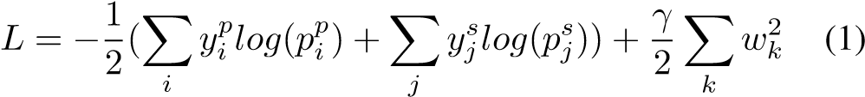

where *yp* and *ys* are one-hot encoded vectors for the labels of plaque (*i* = 0*,*1*,*2*,*3) and stenosis (*j* = 0*,*1*,*2), respectively, and *pp* and *ps* are the softmax output probabilities for the plaque and stenosis, respectively. *wk* is a trainable weight in the network (*k* = 0*,...,Nparam*), where *Nparam* is the total number of trainable parameters in the network. 其中yp和ysan分别是斑块(i = 0，1，2，3)和狭窄(j = 0，1，2)标记的one-hot编码向量，pp和ps分别是斑块和狭窄的softmax输出概率。wkis是网络中可训练的权重(k = 0，...，Nparam)，其中Nparam是网络中可训练参数的总数。

During training, mini-batches of 36 sequences (i.e. segments) were used to minimize the loss function with Adam optimizer [38] with constant learning rate 0*.*001, and a random dropout [39] of 50% was applied in each recurrent layer to prevent overfitting. Training was performed for 50,000 iterations (Fig. 4(a)). To evaluate the effect of data augmentation during training, an identical network was trained without any augmentation and the accuracies during training with and without data augmentation are illustrated in Fig. 4(b). In these figures, the stability and the convergence of the training process with data augmentation are shown, while training without data augmentation shows signs of overfitting on the training set where accuracies on the validation set decrease. 在训练过程中，使用36个序列(即片段)的小批量，以恒定学习率0.001的Adam优化器[38]最小化损失函数，并且在每个递归层中应用50%的随机丢失[39]以防止过度拟合。训练进行了50，000次迭代(图4(a))。为了评估训练期间数据增强的效果，在没有任何增强的情况下训练了相同的网络，并且图4(b)示出了在有和没有数据增强的情况下训练期间的准确度。在这些图中，显示了具有数据增强的训练过程的稳定性和收敛性，而没有数据增强的训练显示了训练集过度拟合的迹象，其中验证集的精度降低。

Unlike in the training phase, where the defined start- and endpoints of a segment were used, during testing, segments were not defined, and labels were predicted along the whole analyzed artery. Therefore, all points along the coronary centerline were classified and labeled by the network. This was performed by feeding the network a fixed-length sequence centered around each centerline point. The fixed-length sequence consisted of 5 cubes with a stride of 5 voxels extracted along the coronary artery centerline. These parameters were optimized in preliminary experiments on the training set. The output probabilities for plaque and stenosis were then assigned to the center of the evaluated sequence. Thereafter, a label for plaque and a label for stenosis was defined for each centerline point by the class having the highest probability in each task separately. 与训练阶段不同，在训练阶段，使用已定义的片段起点和终点，在测试过程中，没有定义片段，而是沿着整个分析动脉预测标签。因此，沿着冠状动脉中心线的所有点都被网络分类和标记。这是通过向网络馈送以每个中心线点为中心的固定长度序列来实现的。固定长度的序列由5个立方体组成，沿着冠状动脉中心线提取5个体素。这些参数在训练集的初步实验中进行了优化。斑块和狭窄的输出概率被分配到评估序列的中心。此后，由在每个任务中具有最高概率的类别分别为每个中心线点定义斑块标签和狭窄标签。

# A. Plaque detection and characterization

To assess the performance of the proposed RCNN for plaque detection and characterization (no plaque, non-calcified, mixed, calcified), we first evaluated the performance for each annotated segment. Table I lists the confusion matrix showing the results. Next, we evaluated the performance of the proposed method for detection of plaque (plaque of any type vs. no plaque), and compared it with plaque detection and characterization at the segment level. These results are summarized in Table II. To allow comparison of the automatic analysis with that of an expert, Table II additionally provides results achieved by the second observer. In brief, for detection of plaque (plaque

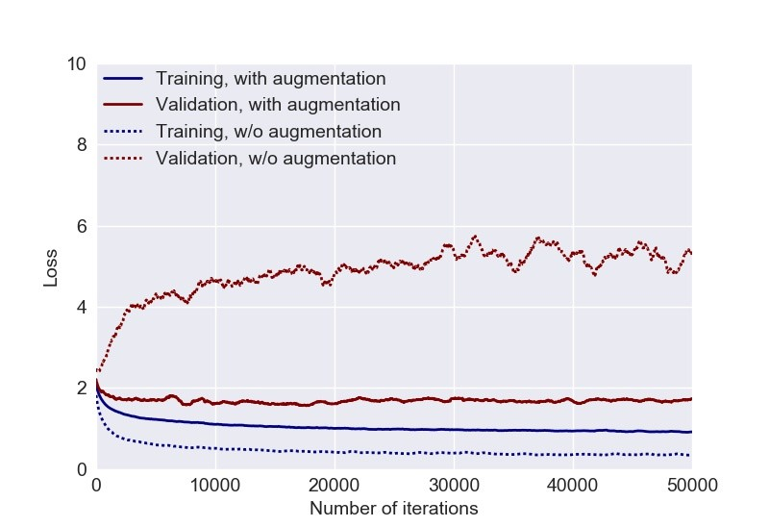

(a)

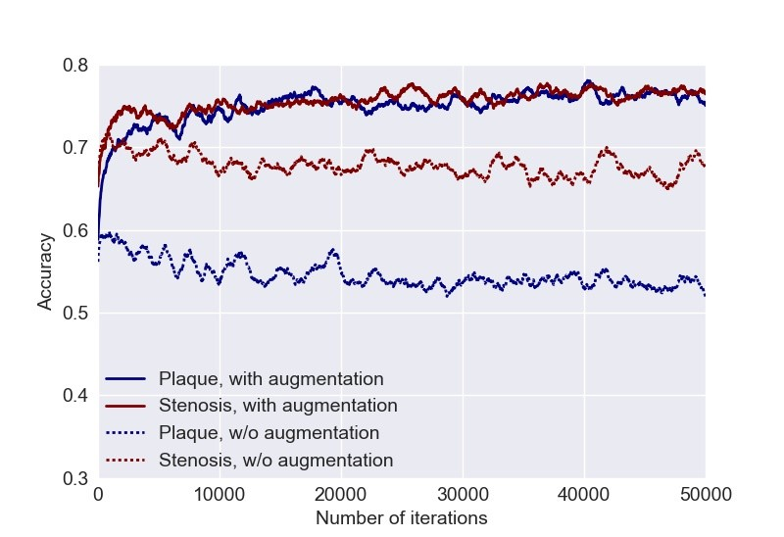

(b)

Figure 4. (a) Training and validation losses during training with and without data augmentation. (b) Validation accuracies for detection and characterization of coronary artery plaque, as well as detection and determination of the anatomical significance of coronary artery stenosis during training with and without data augmentation. （a）在培训期间培训和验证损失，无数据增强。 （b）验证精度，用于检测和表征冠状动脉斑块，以及检测和测定冠状动脉狭窄期间训练期间的冠状动脉狭窄在没有数据增强期间的解剖学意义

of any type vs. no plaque), the proposed method achieved a segment-level accuracy of 0.85 and the second observer reached an accuracy of 0.90. For detection and characterization of plaque (no plaque, non-calcified, mixed, calcified), the proposed method and the second observer achieved segmentlevel accuracies of 0.77 and 0.80 with unweighted *κ* of 0.61 and 0.67, respectively. Finally, to evaluate whether the performance of the method depends on the analyzed artery, Table III lists the performance obtained for the detection and characterization of plaque (no plaque, non-calcified, mixed, calcified) at the segment-level in the different coronary arteries (LAD / LCX / RCA). Plaque was most accurately detected in LCX (0.81) and the least in RCA (0.72). Examples of automatically predicted classification probabilities in different arteries are shown in Fig. 5. An example of an artery with predicted labels for plaque characterization is shown in Fig. 6(b). 为了评估所提出的RCNN的性能进行斑块检测和表征（无斑块，非钙化，混合，钙化），我们首先评估每个注释段的性能。表I列出了显示结果的混淆矩阵。接下来，我们评估了所提出的方法检测斑块的方法（任何类型与斑块的斑块），并将其与斑块检测和表征进行比较。这些结果总结在表II中。为了允许使用专家的自动分析比较表II，表II还提供了第二种观察者实现的结果。简而言之，为了检测斑块（任何类型与斑块的斑块），所提出的方法实现了0.85的段级精度，第二个观察者达到0.90的准确度。对于斑块的检测和表征（无斑块，未钙化，混合，钙化），所提出的方法和第二观察者的分体精度为0.77和0.80，分别为0.61和0.67的未加权κ。最后，为了评估方法的性能是否取决于分析的动脉，表III列出了在不同冠状动物中的分段水平的斑块（无斑块，非钙化，混合，钙化）检测和表征的性能所获得的性能动脉（LAD / LCX / RCA）。在LCX（0.81）中最精确地检测到斑块，最小值在RCA（0.72）中。在图5中示出了不同动脉中的自动预测分类概率的实例。图6（b）中示出了具有预测标签的动脉的示例。

# B. Stenosis detection and characterization

To assess the performance of the proposed RCNN for detection and determination of the anatomical significance

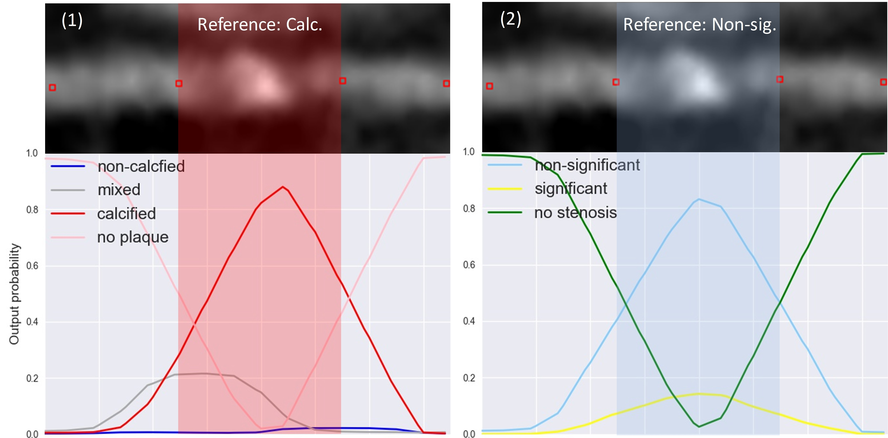

(a)

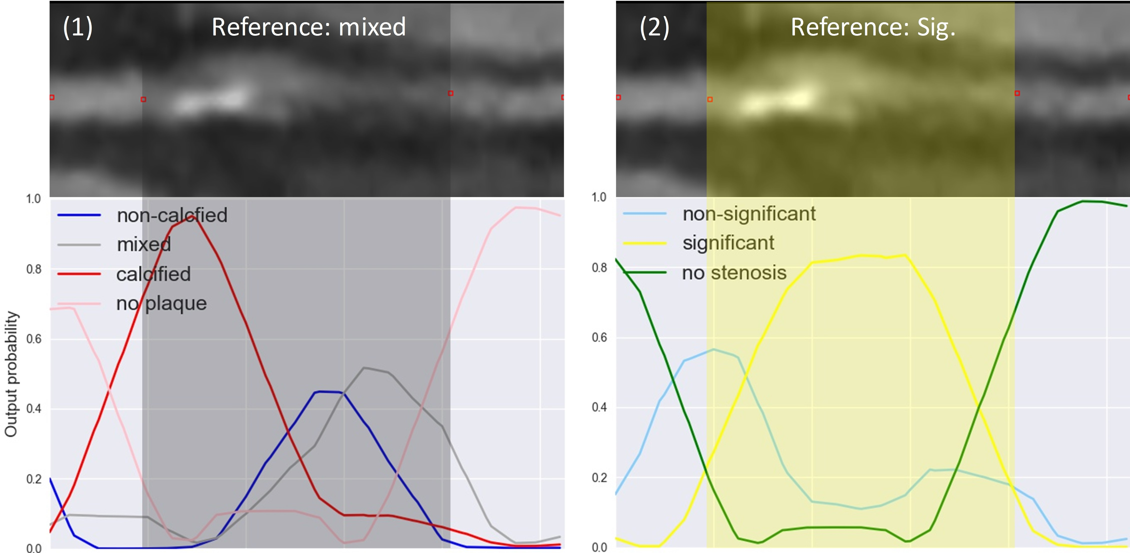

(b)

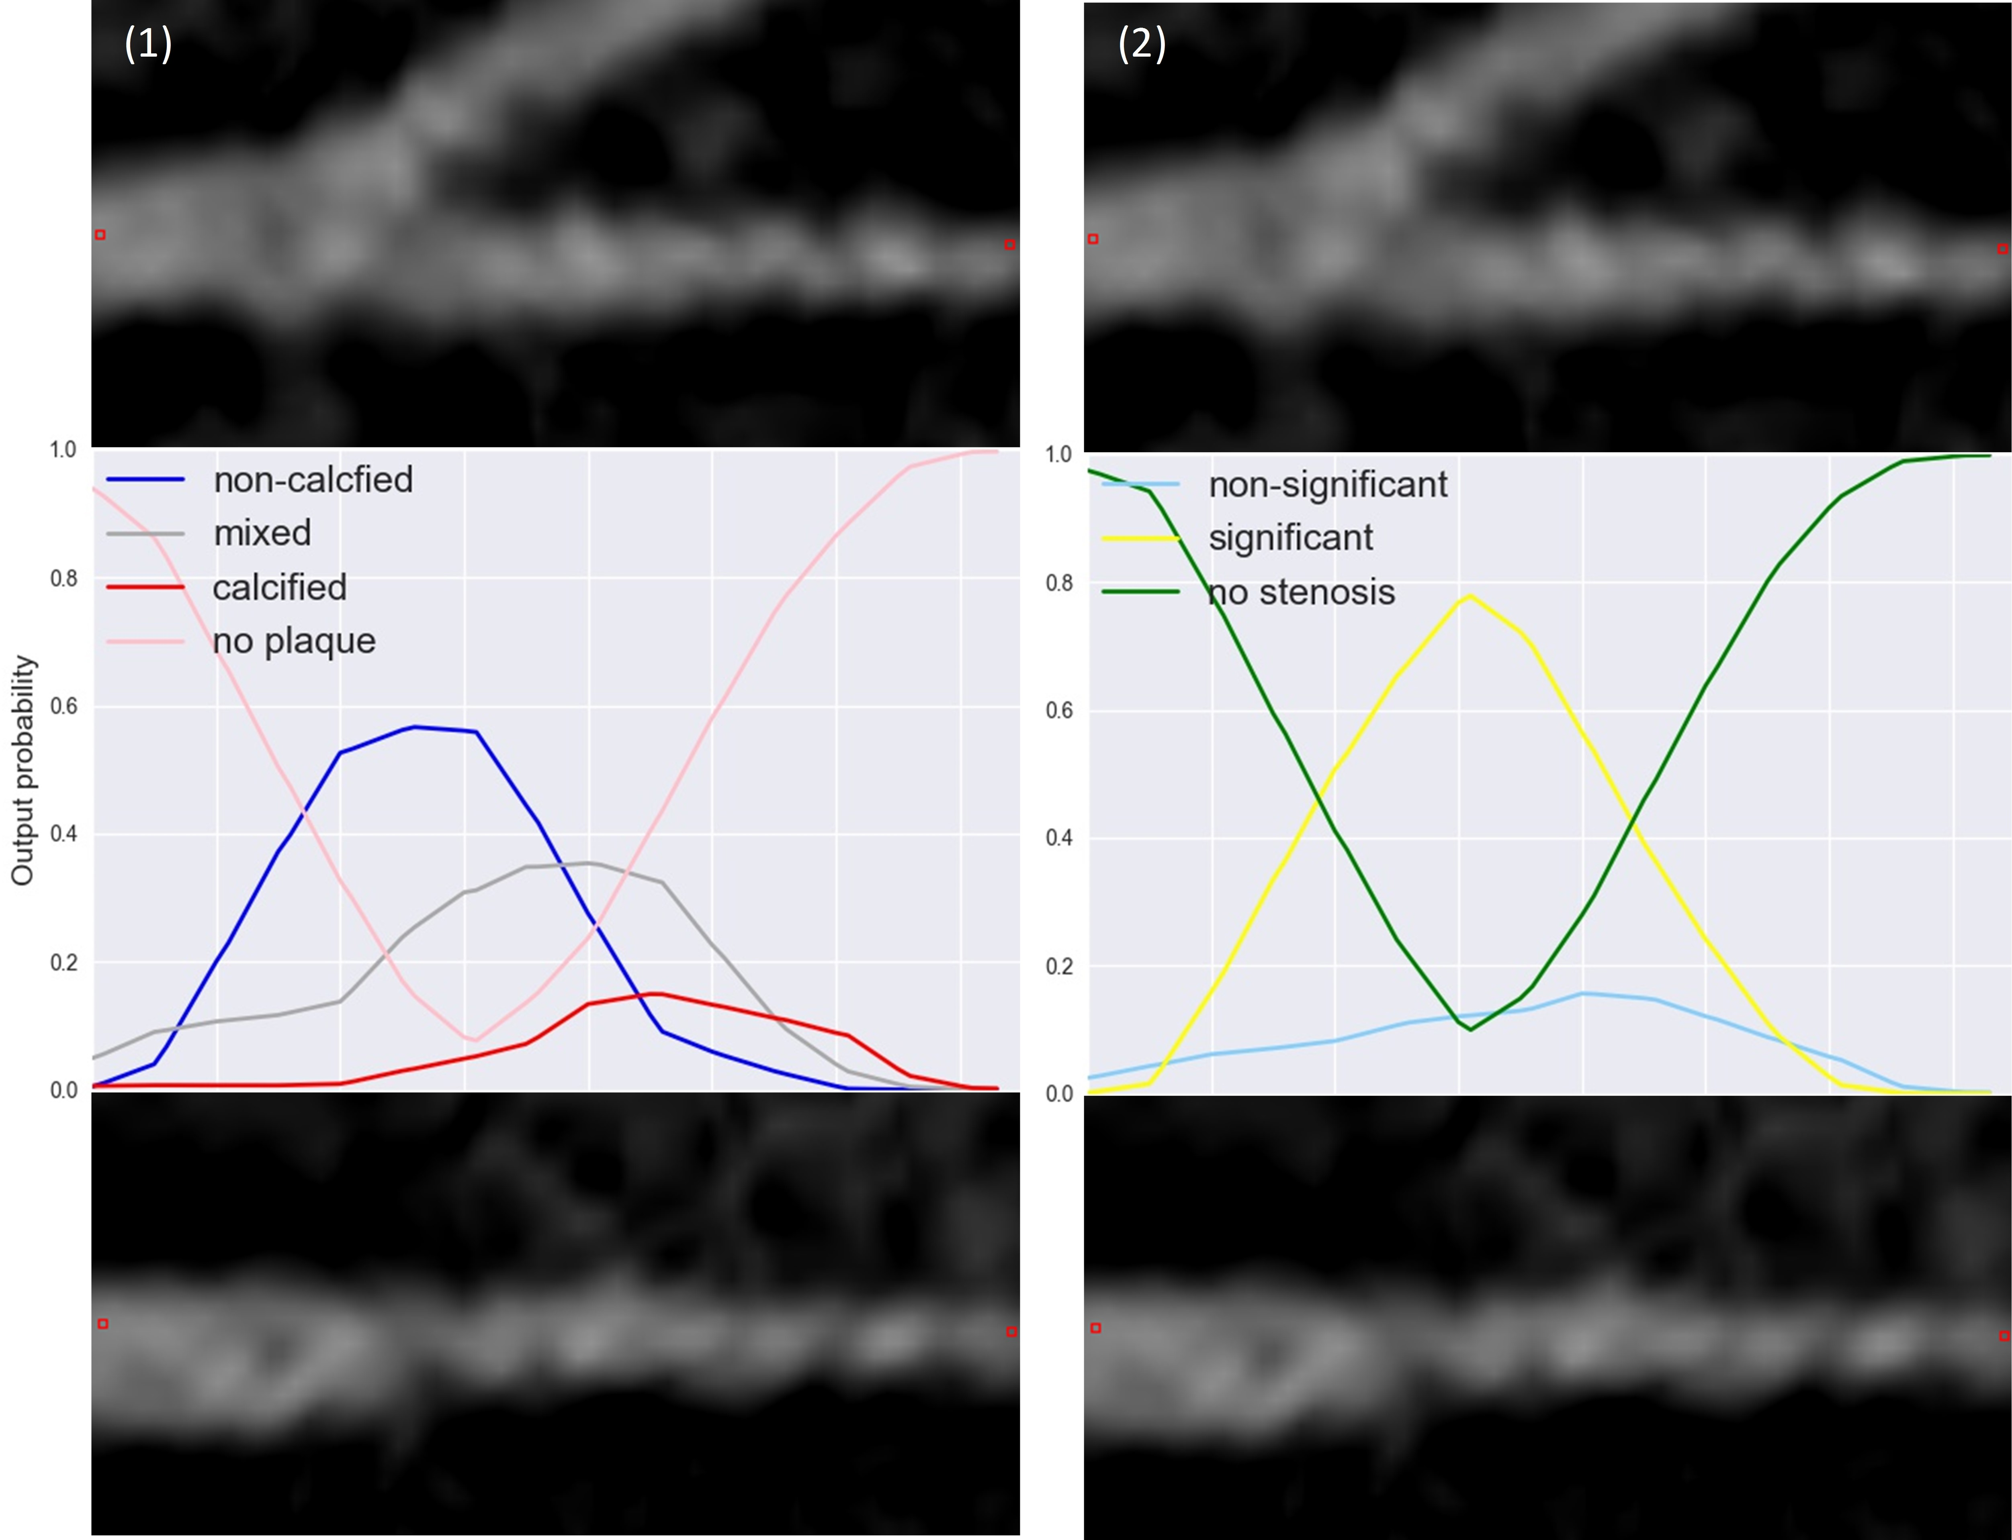

(c)

Figure 5. (a) and (b) are examples of output probabilities for (1) plaque and (2) stenosis classification of a plaque indicated by its manually annotated boundaries and the reference labels (top). Output probabilities for plaque and stenosis classification are shown for each class (bottom). Note that in (a) calcified plaque and non-significant stenosis are correctly detected, while in (b), a mixed plaque with significant stenosis was detected as a calcified plaque with significant stenosis. Non-Sig. = Non-significant stenosis. Sig. = Significant stenosis. Calc. = Calcified plaque. Non-calc. = Non-calcified plaque. (c) An example of output probabilities for (1) plaque and (2) stenosis classification over a bifurcation of an artery in MPR view (top) and a 90◦ rotated MPR view (bottom). Output probabilities for plaque and stenosis classification are shown for each class (middle). Note that as a sudden reduction in the coronary artery lumen diameter occurs distal to bifurcations, in this case, a stenosis was falsely detected. （a）和（b）是（1）斑块的输出概率和（2）斑块的狭窄分类的例子，该斑块由其手动注释的边界和参考标签（顶部）表示。每个类（底部）都显示了斑块和狭窄分类的输出概率。注意，在（a）钙化斑块和非显着的狭窄被正确检测到，而在（b）中，检测到具有显着狭窄的混合斑块作为具有显着狭窄的钙化斑块。非Sig。 =非显着的狭窄。 SIG。 =显着的狭窄。 Calc。 =钙化斑块。Non-calc=非钙化斑块。(1)斑块和(2)在多平面重建视图(上)和90°旋转多平面重建视图(下)中动脉分叉上的狭窄分类的输出概率示例。斑块和狭窄分类的输出概率显示为每个类别(中间)。注意，由于冠状动脉腔直径在分叉远端突然减小，在这种情况下，狭窄被错误地检测到。

of stenosis, we analyzed the results achieved on the segment-, artery- and patient-levels. The obtained confusion matrices are calculated and shown in Table IV. 为了评估所提出的用于检测和确定狭窄的解剖学意义的RCNN的性能，我们分析了在段、动脉和患者水平上获得的结果。计算得到的混淆矩阵，如表四所示。 To get an insight

|  |
| --- |
| Figure 6. An example of a result for an entire artery. (a) MPR view of an artery with reference standard. Each arrow represents a manually annotated segment, its boundaries and the reference labels. Sig. = Significant stenosis, Non-Sig. = Non-significant stenosis. Calc. = Calcified plaque. Non-calc. = Non-calcified plaque. (b) Automatically predicted plaque labels (no-plaque, calcified, and non-calcified: purple, red, and blue overlays, respectively). (c) Automatically predicted stenosis labels (no-stenosis, non-significant, and significant: green, light blue and yellow, respectively). For illustration purposes only, all overlays were extended to a 25×25 voxels around the artery centerline, indicating the analyzed area.整个动脉的结果示例。(a)具有参考标准的动脉的MPR视图。每个箭头代表一个手动注释的线段、其边界和参考标签。西格。=显著狭窄，无信号。=无明显狭窄。Calc。=钙化斑块。非计算。=非钙化斑块。(b)自动预测斑块标签(无斑块、钙化和非钙化:分别为紫色、红色和蓝色覆盖)。(c)自动预测狭窄标签(无狭窄、不显著和显著:分别为绿色、浅蓝色和黄色)。仅出于说明目的，所有覆盖都扩展到动脉中心线周围的25 × 25体素，表示分析区域。 |

Table I

CONFUSION MATRIX SHOWING SEGMENT-LEVEL RESULTS OF DETECTION AND CHARACTERIZATION OF PLAQUE BY CLASSIFICATION INTO

NO-PLAQUE, NON-CALCIFIED PLAQUE, MIXED PLAQUE, AND CALCIFIED PLAQUE. THIS RESULTED WITH AN ACCURACY OF 0.77 AND AN UNWEIGHTED *κ* OF 0.61.

*Segment-level*

*Automatic*

No plaque

Non-calcified

Mixed

Calcified

*Reference*

No-plaque

211

8

4

15

Non-calcified

19

7

2

0

Mixed

4

6

27

27

Calcified

2

11

3

83

into the ability of the method to classify stenosis, Table II lists the performance obtained for detection and determination of the anatomical significance of the stenosis (no stenosis, non significant stenosis, significant stenosis) at the segment, artery- and patient-level. The automatic method achieved accuracy of 0.80, 0.76 and 0,75, and the linearly weighted *κ* of 0.68, 0.66 and 0.67 at the segment-, artery- and patient-level, respectively. For the second observer the accuracies were 0.83, 0.80 and 0.75, and the linearly weighted *κ* were 0.70, 0.72 and 0.70, respectively. Given the importance of the detection of the anatomically significant stenosis, the performance of the automatic method as well as the performance of the second observer for the this task (significant stenosis vs. no stenosis or non-significant stenosis) were evaluated. The automatic method achieved accuracy of 0.94, 0.93 and 0.85 at the segment-, artery- and patient-level, respectively. 为了深入了解该方法对狭窄进行分类的能力，表二列出了在节段、动脉和患者水平上检测和确定狭窄的解剖学意义(无狭窄、无显著狭窄、显著狭窄)所获得的性能。该自动方法在节段、动脉和患者水平上分别获得了0.80、0.76和0.75的准确度以及0.68、0.66和0.67的线性加权κ。对于第二个观测器，精度分别为0.83、0.80和0.75，线性加权κ分别为0.70、0.72和0.70。考虑到检测解剖学上显著狭窄的重要性，评估了自动方法的性能以及该任务的第二个观察者的性能(显著狭窄与无狭窄或非显著狭窄)。自动方法在节段级、动脉级和患者级分别达到了0.94、0.93和0.85的精度。

精确度。)，由所提出的方法和用于斑块和狭窄检测和分类的第二个观察者获得的F1评分和凝聚κ。第二个观察者所获得的结果在括号中给出。对于斑块的分析，显示了在段水平上检测斑块(d .)的性能(斑块相对于无斑块)，以及检测和表征斑块(D.+C .)(无斑块，非钙化，混合，钙化)的性能。对于狭窄的分析，显示了在节段、动脉和患者水平检测显著狭窄(d .)(显著狭窄与无狭窄或无显著狭窄)以及检测和分类狭窄(D.+S .)(无狭窄、无显著狭窄、有显著狭窄)的解剖学意义的性能。

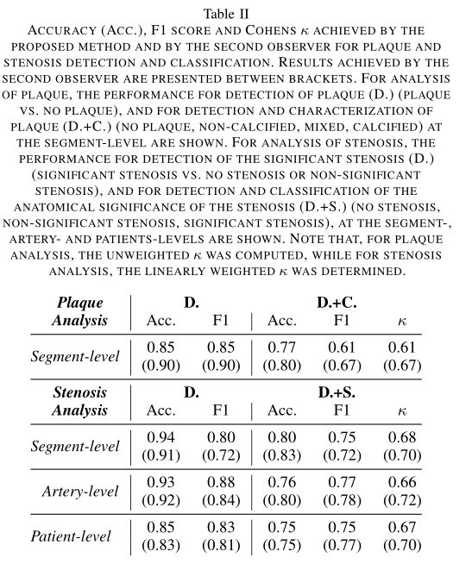

Table III

ACCURACY (ACC.), UNWEIGHTED F1 SCORE AND COHENS *κ* AT THE

SEGMENT-LEVEL FOR PLAQUE AND STENOSIS CHARACTERIZATION FOR

THE THREE MAIN CORONARY ARTERIES (LAD, LCX, RCA). THE NUMBER

OF EVALUATED SEGMENTS PER ARTERY IS INDICATED (N). NOTE THAT, FOR PLAQUE DETECTION AND CHARACTERIZATION, THE UNWEIGHTED *κ* WAS

COMPUTED, WHILE FOR STENOSIS DETECTION AND DETERMINATION OF

THE SIGNIFICANCE OF THE DETECTED STENOSIS, LINEARLY WEIGHTED *κ* WAS DETERMINED.

*Plaque Analysis Stenosis Analysis*

|  |  |  |  |  |  |  |
| --- | --- | --- | --- | --- | --- | --- |
|  | Acc. | F1 | *κ* | Acc. | F1 | *κ* |
| LAD (n=184) | 0.78 | 0.69 | 0.65 | 0.81 | 0.79 | 0.72 |
| LCX (n=96) | 0.81 | 0.59 | 0.62 | 0.80 | 0.65 | 0.60 |
| RCA (n=149) | 0.72 | 0.52 | 0.53 | 0.79 | 0.68 | 0.62 |

For the second observer these were 0.91, 0.92 and 0.83, respectively. Table II also

details these results. Finally, to compare the performance in the different coronary arteries, the performance achieved for the detection and determination of the anatomical significance of the stenosis (no stenosis, non-significant stenosis, significant stenosis) at the segment-level in the three main coronary arteries (LAD / LCX / RCA) was evaluated. The analysis showed that similar accuracies were achieved in all three arteries (0.81 for LAD, 0.80 for LCX and 0.79 for RCA). Detailed results are listed in Table III. Examples of automatically predicted classification probabilities in different arteries are shown in Fig. 5. An example of an artery with predicted labels for stenosis characterization is shown in Fig. 6(c). 对于第二个观察者，它们分别是0.91、0.92和0.83。表二也详细列出了这些结果。最后，为了比较在不同冠状动脉中的表现，评估了在三个主要冠状动脉(LAD / LCX / RCA)的节段水平上检测和确定狭窄(无狭窄、不显著狭窄、显著狭窄)的解剖学意义的表现。分析显示，在所有三条动脉中都达到了相似的准确度(左前降支为0.81，LCX为0.80，右冠状动脉为0.79)。详细结果列于表三。不同动脉中自动预测的分类概率的例子如图5所示。图6(c)显示了带有狭窄特征预测标记的动脉的例子。

# C. Impact of the RCNN architecture

To establish the value of the recurrent nature of the proposed network, an additional experiment was performed in which a network with an identical CNN architecture was utilized, while the RNN was replaced by fully connected (FC) layers (Fig. 7). To analyze different sequence lengths and to aggregate the features extracted by the CNN into one vector, a global max pooling layer was employed after the CNN. This layer

Table IV

CONFUSION MATRICES SHOWING SEGMENT-, ARTERY-AND PATIENT-LEVEL

RESULTS FOR DETECTION AND CHARACTERIZATION OF THE STENOSIS BY

CLASSIFICATION INTO NO-STENOSIS, NON-SIGNIFICANT AND SIGNIFICANT

STENOSIS. ACCURACIES OF 0.80, 0.76 AND 0.75 WERE OBTAINED AT THE

SEGMENT-, ARTERY- AND PATIENT-LEVEL, RESPECTIVELY. THE LINEARLY

WEIGHTED *κ* WERE 0.68, 0.66 AND 0.67 AT THE SEGMENT-, ARTERY- AND PATIENT-LEVEL, RESPECTIVELY.

*Automatic*

*Segment-level*

No stenosis Non-significant Significant

|  |  |  |  |
| --- | --- | --- | --- |
| No-stenosis  *Reference*  Non-significant  Significant | 211  35  1 | 23  112  13 | 4 8  22 |
| *Artery-level* | No stenosis | *Automatic* Non-significant | Significant |
| No-stenosis  *Reference*  Non-significant  Significant | 58  13  0 | 21  64  5 | 3 5  25 |
| *Patient-level* | No stenosis | *Automatic* Non-significant | Significant |

No-stenosis 10 2 1

*Reference*

Non-significant 4 21 6

Significant 0 3 18

was subsequently connected to two FC layers instead of the GRUs. To match the total number of trainable parameters in both architectures, the number of units in each of FC layers was raised from 64 to 192. In total, the network had 341,191 parameters (vs. 340,295 parameters in the RCNN network). To allow a comparison with the proposed RCNN network, this network was trained, validated and tested using the same sets of training, validation and test images. The obtained results are listed in Table V (second row).

# D. Single vs. multi-task classification

Given that plaque and stenoses analyses are related, the classification could be posed as a single multi-class task with seven unique output classes (no plaque, calcified, mixed or non-calcified plaque with non-significant stenosis, calcified, mixed or non-calcified plaque with significant stenosis).

To evaluate the performance of single task classification, two additional networks were examined. The first network utilized an identical RCNN architecture with a single softmax classifier with 7 output units. The second used a CNN-only architecture (as in Section V-C) also with a single softmax classifier with 7 output units. To allow a comparison with the proposed network, these networks were trained, validated and tested using the same sets of training, validation and test images. The obtained results are listed in Table V (first and third rows).

Table V

ACCURACY (ACC.), UNWEIGHTED F1 SCORE AND COHENS *κ* AT THE

SEGMENT-LEVEL FOR PLAQUE AND STENOSIS CHARACTERIZATION USING

FOUR DIFFERENT NETWORK ARCHITECTURES. *CNN* INDICATES THE

NETWORK WHERE THE RECURRENT LAYERS WERE REPLACED BY FULLY

CONNECTED LAYERS. *Single-task* DENOTES THE NETWORK WITH SINGLE

SOFTMAX CLASSIFIER, WHILE *multi-task* DENOTES THE NETWORK WITH

TWO SOFTMAX CLASSIFIERS. NOTE THAT, FOR PLAQUE DETECTION AND

CHARACTERIZATION, THE UNWEIGHTED *κ* WAS COMPUTED, WHILE FOR

STENOSIS DETECTION AND DETERMINATION OF THE SIGNIFICANCE OF THE DETECTED STENOSIS, LINEARLY WEIGHTED *κ* WAS DETERMINED.

*Plaque Analysis Stenosis Analysis*

|  |  |  |  |  |  |  |
| --- | --- | --- | --- | --- | --- | --- |
|  | Acc. | F1 | *κ* | Acc. | F1 | *κ* |
| CNN single-task | 0.53 | 0.41 | 0.39 | 0.62 | 0.60 | 0.46 |
| CNN multi-task | 0.63 | 0.58 | 0.48 | 0.71 | 0.70 | 0.58 |
| RCNN single-task | 0.63 | 0.57 | 0.49 | 0.69 | 0.68 | 0.51 |
| RCNN multi-task | 0.77 | 0.61 | 0.61 | 0.80 | 0.75 | 0.68 |

# E. Comparison with previous work

Most published methods reported segment-level sensitivity and positive predictive value (PPV) for the detection of the anatomically significant stenosis [9]. Shahzad et al. [21] reported a segment-level sensitivity of 0.50 and a PPV of 0.27 for the detection of the anatomically significant stenosis, while Wang et al. [22] reported a sensitivity of 0.28 and a PPV of 0.23. The proposed network achieved a sensitivity of 0.61 and a PPV of 0.65 for detecting significant stenosis. Nonetheless, comparison with these methods is not trivial as these methods required the artery lumen to be first segmented and then the stenosis was detected. Additionally, different studies reported performance using a different evaluation procedure and different sets of patients than the current work. Therefore, a direct comparison of the results should be used only as an indication.

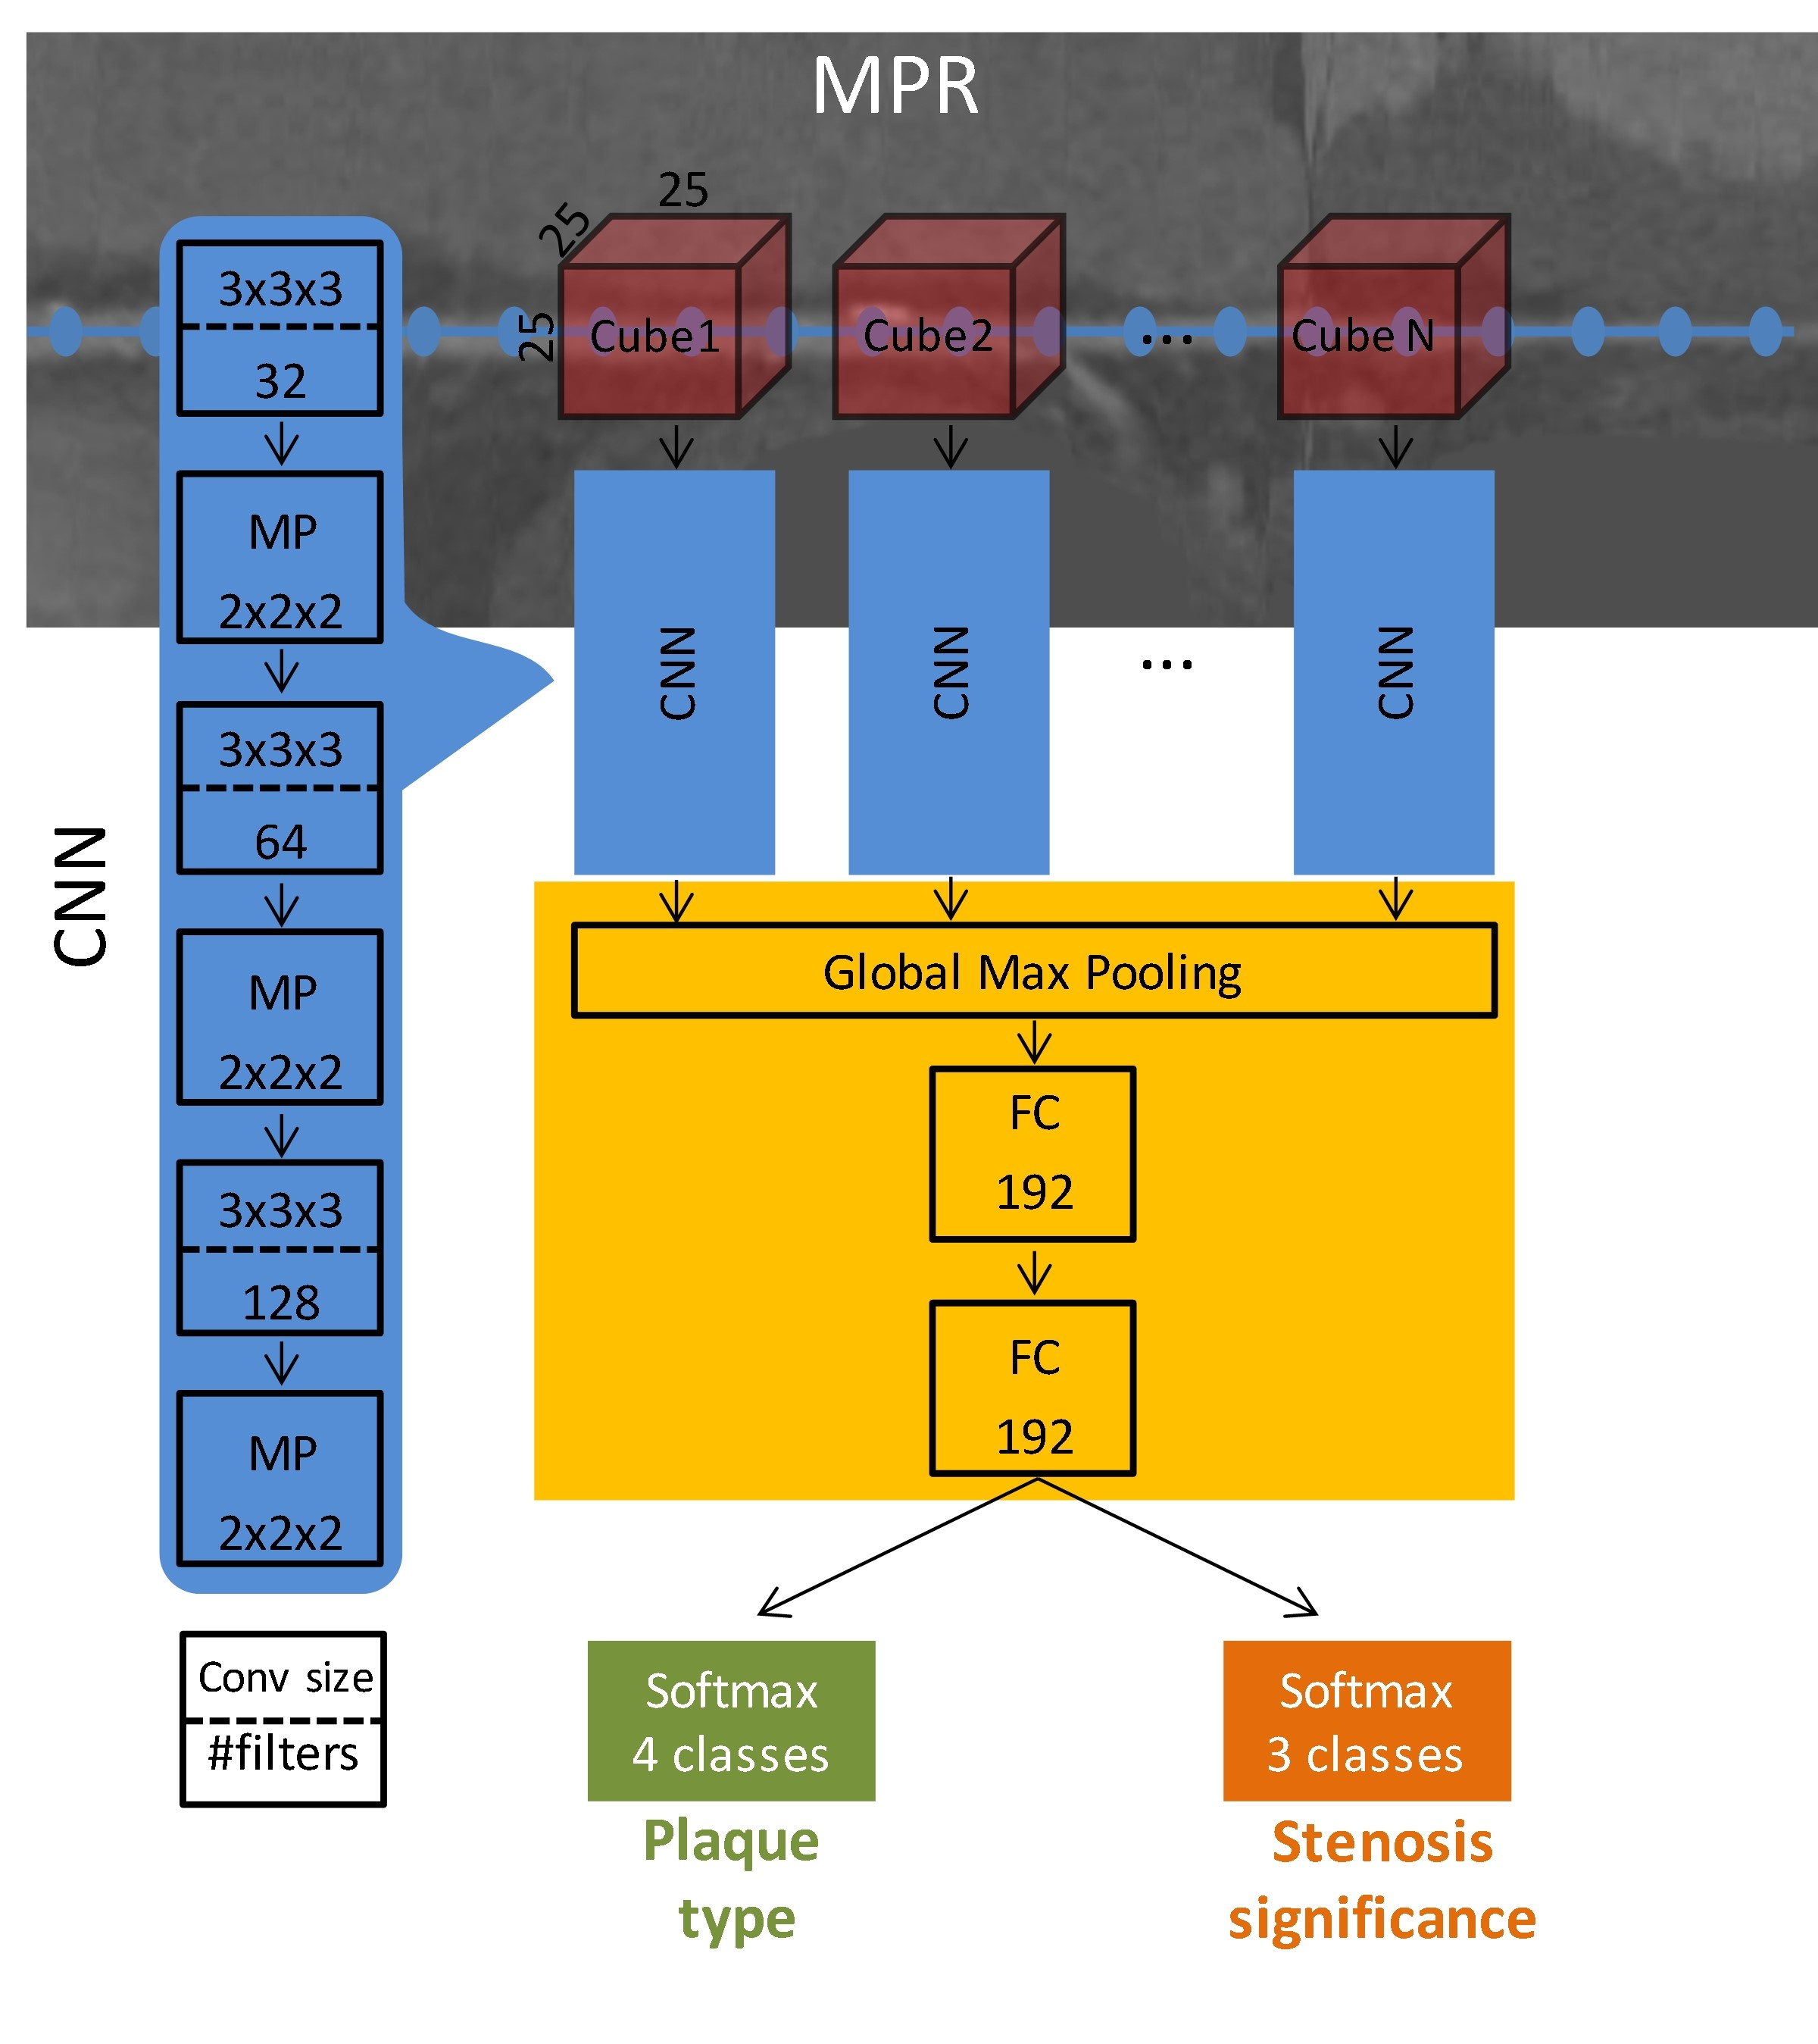

Figure 7. The input of the network is a sequence of cubes extracted from the

MPR along artery centerline. A CNN extracts features out of each 25×25×25 voxels cube, then a global max pooling and two dense (FC - fully connected) layers process the entire sequence. The output of the dense layers is fed into two softmax classifiers to simultaneously characterize plaque and stenosis. To match the total number of parameters compared to the proposed network, 196 units in each of dense layers were used. In total, the network had 341,191 parameters, vs. 340,295 parameters in the proposed network.

Moreover, most methods for the automated detection of the calcified coronary artery plaque perform quantification of the plaque [3]. Such methods usually perform voxel-level analysis which our method does not offer. Methods for detection of noncalcified plaque [14], [15] perform manual or semi-automatic quantification that requires substantial manual interaction by experts. Therefore, a direct comparison with such methods is not feasible.

VI. DISCUSSION AND CONCLUSION

A method for automatic detection and characterization of the coronary artery plaque type, as well as detection and characterization of the anatomical significance of the coronary artery stenosis was presented. The method employs an RCNN that analyzes an MPR view of a coronary artery extracted from a CCTA scan using the coronary artery centerline. The RCNN utilizes a 3D CNN that computes image features from 3D volumes extracted along the coronary artery centerline. Subsequently, an RNN analyzes the computed image features to perform both classification tasks. Unlike most previous methods that detect and characterize coronary artery plaque and stenosis relying on the coronary artery lumen segmentation [9], the proposed method requires only the coronary artery centerline as an input along with the CCTA image.

The presented results reveal that detection and characterization of coronary artery plaque can be performed accurately, but with moderate reliability (Table I and Table II). For both plaque detection and plaque characterization, the second observer only achieved slightly better performance than the proposed method (Table II) indicating the complexity of the task. Nevertheless, the method was accurate in discriminating segments with plaque from those without any plaque. This is clinically important as absence of plaque does not lead to treatment. Moreover, further analysis of plaque characterization revealed that differentiation of the mixed plaque from the calcified and non-calcified plaque remains challenging. This is not surprising given that the mixed plaque contains both calcified and non-calcified components and that the distinction between mixed and calcified plaque, as well as between mixed and non-calcified plaque, is not clearly defined as illustrated in Fig. V. To address this, the automatic method could perform detection of calcified and non-calcified components only, and the obtained results could be merged into calcified, non-calcified and mixed plaque based on their spatial distribution. In addition, it would be interesting to segment plaque on a voxel-level, but obtaining voxel-wise reference is extremely labor intensive and requires a very experienced expert. Furthermore, analysis of the results per coronary artery (Table III) reveals that plaque characterization achieves a slightly lower performance in segments located in the RCA than in LAD or LCX. This might be caused by the more prominent cardiac motion artifacts in the RCA compared to the other two arteries [40].

Anatomically significant stenosis could potentially lead to myocardial ischemia (i.e. functionally significant stenosis), and clinical guidelines suggest that different grades of stenosis in the coronary artery should be managed differently [7]. Our experiments demonstrate that the proposed method is able to detect and determine the anatomical significance of coronary artery stenosis accurately with excellent reliability (Table II and Table IV). For detection and characterization of the anatomical significance of a stenosis, the proposed method achieved a performance approaching the level of the second observer (Table II). Moreover, we investigated whether the method is able to identify patients with anatomically significant stenosis. This is especially important as patients having such stenosis are usually referred to further functional testing and to invasive coronary angiography to measure fractional flow reserve (FFR). FFR determines the functional significance of the stenoses, and hence, establishes the patient’s treatment strategy. Our results reveal that patients with anatomically significant stenosis on CCTA are detected with high accuracy (Table II). However, one patient without stenosis was identified as having a significant stenosis (Table IV). An examination of the CCTA image of this patient revealed that although no artifacts were present, a coronary artery bifurcation was mistakenly detected as significant stenosis in one of the patients’ arteries. Moreover, in this work, only two distinct degrees of stenosis were differentiated; below and above 50% of luminal narrowing. Future work may investigate automatic classification of additional clinically relevant stenotic grades, e.g. *<*25% or *>*70%, or automatic estimation of stenosis degree, i.e. percentage of luminal narrowing. Nevertheless, for both tasks, a larger training set of patients with manual annotations would be required.

The contribution of the recurrent nature of the proposed network was evaluated. The results show clear advantage of the proposed recurrent architecture over the network containing no recurrent units (Table V). This is in agreement with our assumption that a sequential analysis of several small volumes along the coronary artery is needed to aggregate the knowledge of the entire analyzed region rather than just locally (e.g. a single volume). A similar concept was reported by Ng et al. [28], where incorporating information across video frames enabled better video classification. Possibly, given a sufficiently large and diverse data set, a deeper CNN-only (e.g. 3D UNet [41]), analyzing a large single volume along the artery, could be employed to perform the presented analyses. However, obtaining such a large data set remains highly challenging, and employing deep networks, typically used for analysis of natural images (e.g. ResNet [42]), is likely not beneficial due to scarcity of the manually labeled training data.

Unlike most methods for coronary artery plaque and stenosis classification that depend on the extracted artery centerline followed by arterial lumen segmentation [9], the proposed method relies only on the extracted artery centerline. Arterial lumen segmentation is far from trivial task, which occasionally requires substantial manual interaction, especially in diseased population with heavily calcified arteries. We have here prevented potential error propagation by omitting this step. To extract coronary artery centerlines, we have employed our previously designed method for artery centerline extraction [25]. However, any other manual, semi-automatic or automatic method could be employed instead. Although employing the extracted centerlines and the subsequent analysis of the MPR images simplify plaque and stenosis classification, small errors in centerline extraction might lead to errors and therefore negatively affect the overall performance. To mitigate impact of such errors, we trained the RCNN with augmented centerlines, simulating small inaccuracies (Fig.4b). Future work might investigate direct classification of plaque and stenosis from acquired CCTA images, omitting the intermediate centerline extraction.

In this work, we have treated plaque and stenosis characterization as two different tasks, that were performed jointly. Although this halved the time of inference (1.8 seconds per artery on average), it has a limitation. Given that the parameters of the two softmax classifiers in the network differ, a physiologically impossible scenario, where a plaque is not detected while a stenosis is detected, can occur. Although in our experiments this was the case only in less than 1.5% of the cases, future work could address this either by modifying the network architecture preventing such scenario, or by applying a high penalty for such cases in the loss function of the network. A single task network would prevent such a scenario. Nevertheless, experiments, comparing the proposed multi-task approach against networks with single softmax classifier each, demonstrate superior performance of the multi-task approach (Table V, first and third rows vs. second and fourth rows). The limited number of training samples may have prevented the single-task networks from generalizing well even with a relatively small network. Moreover, although the architecture of the RCNN was determined in preliminary experiments using the training set, a systematic extensive grid-search or other hyper-parameter optimization methods were not performed.

Addressing this might further improve the results. In the manual annotations defining the reference standard, a single label was assigned to a whole segment of the coronary artery containing plaque. Separating these segments to their local components might lead to different labels. Consequently, the identified start- and end-points of the automatically detected plaque and stenosis are not in full agreement with the reference annotations (see Fig. 6 and Fig. V). Furthermore, coronary artery bifurcations were not manually annotated and the network was not trained to detect these as a separate class. As a sudden reduction in the coronary artery lumen diameter occurs distal to bifurcations [43], a stenosis might be mistakenly detected (see example illustrated in Fig. V). Future work might address these limitations by modifying the reference standard so that each voxel in the arterial wall or each cross-section of the arterial lumen is annotated and the coronary artery bifurcations are indicated. Besides bifurcations, imaging artefacts caused by routinely used step-and-shoot protocol could affect performance of the method. Nonetheless, a qualitative evaluation of the results revealed that arterial segments containing such image artifacts were not incorrectly detected as having plaque or stenosis. Note that these regions were not included in the manual annotations either. Finally, the current study employed clinically obtained CCTA scans from a single vendor. Modern scanners applying new techniques (e.g. high-pitch spiral, 320detector row) may improve image quality and potentially enable further increase in the performance of the here proposed method. Moreover, further studies are needed to evaluate the proposed method using a larger set of scans from different vendors and medical centers.

To conclude, this study presented an algorithm, based on a recurrent convolutional neural network, for automatic detection and characterization of coronary artery plaque, as well as detection and characterization of the anatomical significance of coronary artery stenosis. To the best of our knowledge, we are the first to propose an automatic method for both plaque and stenosis characterizations. This may enable automated triage of patients to those without coronary plaque, and those with coronary plaque and stenosis in need for further cardiovascular investigation.

ACKNOWLEDGMENTS

This study was financially supported by the project FSCAD, funded by the Netherlands Organization for Health Research and Development (ZonMw) in the framework of the research programme IMDI (Innovative Medical Devices Initiative); project 104003009.

REFERENCES

1. D. Mozaffarian, E. J. Benjamin, A. S. Go, D. K. Arnett, M. J. Blaha, M. Cushman, S. R. Das, S. de Ferranti, J.-P. Despres, H. J. Fullerton´ *et al.*, “Heart disease and stroke statistics - 2016 update,” *Circulation*, vol. 133, no. 4, pp. e38–e360, 2016.
2. G. Raff, A. Abidov, S. Achenbach, D. Berman, L. Boxt, M. Budoff, V. Cheng, T. DeFrance, J. Hellinger, R. Karlsberg *et al.*, “SCCT guidelines for the interpretation and reporting of coronary computed tomographic angiography,” *Journal of Cardiovascular Computed Tomography*, vol. 3, no. 2, pp. 122–136, 2009.
3. J. M. Wolterink, T. Leiner, B. D. De Vos, J.-L. Coatrieux, B. M. Kelm, S. Kondo, R. A. Salgado, R. Shahzad, H. Shu, M. Snoeren *et al.*, “An evaluation of automatic coronary artery calcium scoring methods with cardiac CT using the orCaScore framework,” *Medical Physics*, vol. 43, no. 5, pp. 2361–2373, 2016.
4. R. Virmani, A. P. Burke, A. Farb, and F. D. Kolodgie, “Pathology of the vulnerable plaque,” *Journal of the American College of Cardiology*, vol. 47, no. 8 Supplement, pp. C13–C18, 2006.
5. S. Achenbach, “Can CT detect the vulnerable coronary plaque?” *The International Journal of Cardiovascular Imaging (formerly Cardiac Imaging)*, vol. 24, no. 3, pp. 311–312, 2008.
6. A. Cassar, D. R. Holmes Jr, C. S. Rihal, and B. J. Gersh, “Chronic coronary artery disease: diagnosis and management,” in *Mayo Clinic Proceedings*, vol. 84, no. 12. Elsevier, 2009, pp. 1130–1146.
7. R. C. Cury, S. Abbara, S. Achenbach, A. Agatston, D. S. Berman, M. J. Budoff, K. E. Dill, J. E. Jacobs, C. D. Maroules, G. D. Rubin *et al.*, “CAD-RADSTM coronary artery disease–reporting and data system. an expert consensus document of the society of cardiovascular computed tomography (SCCT), the american college of radiology (ACR) and the north american society for cardiovascular imaging (NASCI). endorsed by the american college of cardiology,” *Journal of Cardiovascular Computed Tomography*, vol. 10, no. 4, pp. 269–281, 2016.
8. M. J. Budoff, D. Dowe, J. G. Jollis, M. Gitter, J. Sutherland, E. Halamert, M. Scherer, R. Bellinger, A. Martin, R. Benton *et al.*, “Diagnostic performance of 64-multidetector row coronary computed tomographic angiography for evaluation of coronary artery stenosis in individuals without known coronary artery disease: results from the prospective multicenter ACCURACY trial,” *Journal of the American College of Cardiology*, vol. 52, no. 21, pp. 1724–1732, 2008.
9. H. Kiris¸li, M. Schaap, C. Metz, A. Dharampal, W. B. Meijboom, S.-L. Papadopoulou, A. Dedic, K. Nieman, M. De Graaf, M. Meijs *et al.*, “Standardized evaluation framework for evaluating coronary artery stenosis detection, stenosis quantification and lumen segmentation algorithms in computed tomography angiography,” *Medical Image Analysis*, vol. 17, no. 8, pp. 859–876, 2013.
10. A. Arbab-Zadeh and J. Hoe, “Quantification of coronary arterial stenoses by multidetector CT angiography in comparison with conventional angiography: methods, caveats, and implications,” *JACC: Cardiovascular Imaging*, vol. 4, no. 2, pp. 191–202, 2011.
11. J. M. Wolterink, T. Leiner, B. D. de Vos, R. W. van Hamersvelt, M. A. Viergever, and I. Isgum, “Automatic coronary artery calcium scoringˇ in cardiac CT angiography using paired convolutional neural networks,” *Medical Image Analysis*, vol. 34, pp. 123–136, 2016.
12. N. Lessmann, B. van Ginneken, M. Zreik, P. A. de Jong, B. D. de Vos, M. A. Viergever, and I. Isgum, “Automatic calcium scoring in low-doseˇ chest CT using deep neural networks with dilated convolutions,” *IEEE Transactions on Medical Imaging*, vol. 37, pp. 615–625, 2018.
13. R. Shadmi, V. Mazo, O. Bregman-Amitai, and E. Elnekave, “Fullyconvolutional deep-learning based system for coronary calcium score prediction from non-contrast chest CT,” in *IEEE 15th International Symposium on Biomedical Imaging (ISBI 2018)*, 2018, pp. 24–28.
14. T. Schepis, M. Marwan, T. Pflederer, M. Seltmann, D. Ropers, W. G. Daniel, and S. Achenbach, “Quantification of noncalcified coronary atherosclerotic plaques with dual source computed tomography: comparison to intravascular ultrasound,” *Heart*, pp. hrt–2009, 2009.
15. D. Dey, T. Schepis, M. Marwan, P. J. Slomka, D. S. Berman, and

S. Achenbach, “Automated three-dimensional quantification of noncalcified coronary plaque from coronary CT angiography: comparison with intravascular US,” *Radiology*, vol. 257, no. 2, pp. 516–522, 2010.

1. S. Mittal, Y. Zheng, B. Georgescu, F. Vega-Higuera, S. K. Zhou, P. Meer, and D. Comaniciu, “Fast automatic detection of calcified coronary lesions in 3D cardiac CT images,” in *International Workshop on Machine Learning in Medical Imaging*. Springer, 2010, pp. 1–9.
2. M. A. Zuluaga, I. E. Magnin, M. H. Hoyos, E. J. D. Leyton, F. Lozano, and M. Orkisz, “Automatic detection of abnormal vascular crosssections based on density level detection and support vector machines,” *International Journal of Computer Assisted Radiology and Surgery*, vol. 6, no. 2, pp. 163–174, 2011.
3. S. Sankaran, M. Schaap, S. C. Hunley, J. K. Min, C. A. Taylor, and L. Grady, “HALE: Healthy area of lumen estimation for vessel stenosis quantification,” in *International Conference on Medical Image Computing and Computer-Assisted Intervention*. Springer, 2016, pp. 380–387.
4. E. J. Halpern and D. J. Halpern, “Diagnosis of coronary stenosis with CT angiography: comparison of automated computer diagnosis with expert readings,” *Academic Radiology*, vol. 18, no. 3, pp. 324–333, 2011.
5. Y. Xu, G. Liang, G. Hu, Y. Yang, J. Geng, and P. K. Saha, “Quantification of coronary arterial stenoses in CTA using fuzzy distance transform,” *Computerized Medical Imaging and Graphics*, vol. 36, no. 1, pp. 11–24, 2012.
6. R. Shahzad, T. van Walsum, H. Kirisli, H. Tang, C. Metz, M. Schaap, L. van Vliet, and W. Niessen, “Automatic stenoses detection, quantification and lumen segmentation of the coronary arteries using a two point centerline extraction scheme,” in *MICCAI 2012 workshop proceedings*, 2012.
7. C. Wang, R. Moreno, and O. Smedby, “Vessel segmentation using implicit¨ model-guided level sets,” in *MICCAI Workshop” 3D Cardiovascular Imaging: a MICCAI segmentation Challenge”, Nice France, 1st of October 2012.*, 2012.
8. A. Broersen, P. Kitslaar, M. Frenay, and J. Dijkstra, “Frenchcoast: fast, robust extraction for the nice challenge on coronary artery segmentation of the tree,” in *Proc. of MICCAI Workshop 3D Cardiovascular Imaging: a MICCAI Segmentation Challenge*, 2012.
9. Y. LeCun, Y. Bengio, and G. Hinton, “Deep learning,” *Nature*, vol. 521, no. 7553, pp. 436–444, 2015.
10. J. M. Wolterink, R. W. van Hamersvelt, M. A. Viergever, T. Leiner, and I. Isgum, “Coronary artery centerline extraction in cardiac CTˇ angiography using a CNN-based orientation classifier,” *Medical image analysis*, 2018.
11. J. Donahue, L. Anne Hendricks, S. Guadarrama, M. Rohrbach, S. Venugopalan, K. Saenko, and T. Darrell, “Long-term recurrent convolutional networks for visual recognition and description,” in *Proceedings of the IEEE Conference on Computer Vision and Pattern Recognition*, 2015, pp. 2625–2634.
12. A. Karpathy and L. Fei-Fei, “Deep visual-semantic alignments for generating image descriptions,” in *Proceedings of the IEEE Conference on Computer Vision and Pattern Recognition*, 2015, pp. 3128–3137.
13. J. Y.-H. Ng, M. Hausknecht, S. Vijayanarasimhan, O. Vinyals, R. Monga, and G. Toderici, “Beyond short snippets: Deep networks for video classification,” in *Proceedings of the IEEE Conference on Computer Vision and Pattern Recognition*. IEEE, 2015, pp. 4694–4702.
14. M. Liang and X. Hu, “Recurrent convolutional neural network for object recognition,” in *Proceedings of the IEEE Conference on Computer Vision and Pattern Recognition*, 2015, pp. 3367–3375.
15. W. De Mulder, S. Bethard, and M.-F. Moens, “A survey on the application of recurrent neural networks to statistical language modeling,” *Computer Speech & Language*, vol. 30, no. 1, pp. 61–98, 2015.
16. R. P. Poudel, P. Lamata, and G. Montana, “Recurrent fully convolutional neural networks for multi-slice MRI cardiac segmentation,” in *Reconstruction, Segmentation, and Analysis of Medical Images*. Springer, 2016, pp. 83–94.
17. G. Litjens, T. Kooi, B. E. Bejnordi, A. A. A. Setio, F. Ciompi, M. Ghafoorian, J. A. van der Laak, B. van Ginneken, and C. I. Snchez,

“A survey on deep learning in medical image analysis,” *Medical Image Analysis*, vol. 42, no. Supplement C, pp. 60 – 88, 2017.

1. S. Andermatt, S. Pezold, and P. Cattin, “Multi-dimensional gated recurrent units for the segmentation of biomedical 3D-data,” in *Deep Learning and Data Labeling for Medical Applications*. Springer, 2016, pp. 142–151.
2. W. Xue, G. Brahm, S. Pandey, S. Leung, and S. Li, “Full left ventricle quantification via deep multitask relationships learning,” *Medical Image Analysis*, vol. 43, pp. 54–65, 2018.
3. S. Ioffe and C. Szegedy, “Batch normalization: Accelerating deep network training by reducing internal covariate shift,” in *Proceedings of The 32nd International Conference on Machine Learning*, 2015, pp. 448–456.
4. K. Cho, B. Van Merrienboer, C. Gulcehre, D. Bahdanau, F. Bougares,¨ H. Schwenk, and Y. Bengio, “Learning phrase representations using RNN encoder-decoder for statistical machine translation,” *arXiv preprint* [*arXiv:1406.1078*,](http://arxiv.org/abs/1406.1078) 2014.
5. X. Glorot, A. Bordes, and Y. Bengio, “Deep sparse rectifier neural networks,” in *International Conference on Artificial Intelligence and Statistics*, 2011, pp. 315–323.
6. D. P. Kingma and J. Ba, “Adam: A method for stochastic optimization,” *arXiv preprint* [*arXiv:1412.6980*,](http://arxiv.org/abs/1412.6980) 2014.
7. N. Srivastava, G. Hinton, A. Krizhevsky, I. Sutskever, and R. Salakhutdinov, “Dropout: A simple way to prevent neural networks from overfitting,” *The Journal of Machine Learning Research*, vol. 15, no. 1, pp. 1929–1958, 2014.
8. C. Hong, C. R. Becker, A. Huber, U. J. Schoepf, B. Ohnesorge, A. Knez, R. Bruning, and M. F. Reiser, “ECG-gated reconstructed multi–detector row CT coronary angiography: effect of varying trigger delay on image quality,” *Radiology*, vol. 220, no. 3, pp. 712–717, 2001.
9. O.¨ C¸ic¸ek, A. Abdulkadir, S. S. Lienkamp, T. Brox, and O. Ronneberger, “3D U-Net: learning dense volumetric segmentation from sparse annotation,” in *International Conference on Medical Image Computing and Computer-Assisted Intervention*. Springer, 2016, pp. 424–432.
10. K. He, X. Zhang, S. Ren, and J. Sun, “Deep residual learning for image recognition. corr, vol. abs/1512.03385,” 2015.
11. L. Antiga and D. A. Steinman, “Robust and objective decomposition and mapping of bifurcating vessels,” *IEEE Transactions on Medical Imaging*, vol. 23, no. 6, pp. 704–713, 2004.